SDD Project

Contents

Stage 1: Defining & Understanding the Problem 5

Defining and understanding the problem 5

Description of the problem (1 page max) 5

Needs of the client (1 page max) 5

Idea Generation (2 pages max) 6

Selection of an Idea (1 page max) 8

Define Boundaries for the Software (half page max) 8

Preliminary Timeline (gantt chart) 8

Issues relevant to a proposed solution 9

Determine if an existing solution can be used (3 pages max) 9

Select and justify an appropriate software development approach (1 page max) 11

Design specifications 12

list of specifications of the software (1 page max) 12

Proposed architecture of the programmed solution (2 pages max) 13

The considerations needed to be taken in regard to the user in the development of this software solution (2 pages max) 15

Demonstrate the algorithm specifications to be used and identify a range of algorithmic logic that will be required in your solution 17

preliminary data dictionary 19

Create preliminary context diagram, IPO, Structure Chart and System Flowcharts for your proposed software solution 20

Communication issues between client and developer 26

Explain how you will consult with the client throughout the project, and include and plan for inclusion of the client’s perspective and feedback (2 pages max) 26

Explain how you will involve and empower the client in the development process (1 page max) 28

Document this communication and evaluate its effectiveness using a quantifiable measure. (1 page max) 29

Quality assurance 30

Describe the processes that will be used to guarantee a quality product (1 page max) 30

Define the criteria that will be used to judge the quality of this software project. (2 pages max) 31

Explain the criteria for ‘quality’ and the steps required for ongoing assurance of quality in your software solution. (1 page max) 33

Stage 2: Planning & Designing Software Solutions 34

Standard Algorithms 34

List and describe all standard logic to be used in the software solution (2 page max) 34

Custom-designed logic used in software solutions 35

Demonstrate your solution in algorithm form 35

Develop and document Test Data required to sufficiently test the algorithm solution. 38

Where possible, desk check your algorithms. Note any changes made as a result. 39

Standard modules used in software solutions 40

Identify and justify one module in your software solution that might be more widely used. Discuss what would be required to implement it as a library routine (1 page max) 40

Identify and describe two library routines you are using from the source language or IDE. Describe what makes them effective routines to be used. (2 pages max) 41

Documentation of the overall software solution 42

Refine your Data Dictionary to document Class and method variables, broken down by class. Represent a range of data types. This should NOT be exhaustive of every variable in your program, but should show a range of data types to serve particular purposes. 42

Describe the implementation and use of at least one CASE tool during your development (1 page max) 42

Interface Design in Software Solutions 43

Discuss issues that will affect your interface design (1 page max) 43

Create a storyboard with complete screen designs for your software solution. Annotate your screen design to demonstrate screen design considerations. Implement a prototype of your interface design using a UI design tool. 44

Factors to be considered when selecting the programming language to be used 51

Justify your choice of programming language for the project you have created. (1 page max) 51

Factors to be considered when selecting the technology to be used 52

Specify the performance requirements of the project. (1 page max) 52

Benchmark one routine in your project and explain and apply the results (2 pages max) 53

Stage 3: Implementation of Software Solutions 54

Implementation of the design using an appropriate language 54

Implement your Class structure in your chosen IDE with corresponding methods and data structures implemented from your algorithms and solution design. 54

Continually update your data dictionary to match implementation 54

Techniques in developing well written code 55

During development adhere to good programming practice: 55

Explain how you have coded to increase maintainability of your code. (1 page with examples) 55

Document five errors that you corrected during development (3 pages max) 55

Explain three methods you used to detect and correct errors you encountered (1 page max) 55

Explain two software debugging tools you used in your IDE and provide screenshots of them in action. (1 page max) 55

Documentation of a software solution 56

Create appropriate user documentation 56

Hardware environment to enable implementation of the software solution 57

Explain Hardware requirements to run your software solution including minimum requirements, any additional hardware or peripherals required / desirable, and any appropriate device drivers. Describe any differences in these to the original design specifications. (2 pages max) 57

System Documentation 58

Refine your IPO (at least 3 levels), DFD, Structure Chart, Context Diagram and System flowchart for your software solution. 58

Stage 4: Testing and Evaluation of Software Solutions 59

Testing the software solution 59

Evaluate the success of the completed software solution against the criteria (understanding of the problem and specifications) determined earlier in the documentation. (2 pages max) 59

Test the solution at all levels with original test data (Module, Program, System) and document results (2 pages max) 59

Explain the types of test data used on the software solution (1 page max) 59

Demonstrate the actual vs expected test output of a given algorithm (1 page max) 59

Post Implementation Review 60

Document a discussion with the client including aims and what was achieved (max half page) 60

Document client satisfaction / dissatisfaction with the result. (1 page max) 60

Obtain client sign-off on completion of the project. 60

Stage 5: Maintaining Software Solutions 61

Modifying Code to meet changed requirements 61

Explain three changes that might need to be made in future maintenance of the software (1 page max) 61

Explain how you would locate the changes to be made in the software (half page max) 61

Explain which documents and what parts of the documents you would need to update in order to keep the development documentation current. (half page max) 61

Project Management Techniques 62

summary of project management techniques used throughout the project (3 pages max) 62

# Stage 1: Defining & Understanding the Problem

## Defining and understanding the problem

### Description of the problem (1 page max)

The aim of the project is to design and create a software program or game that will be beneficial or enjoyable towards the users of the software. The game that is being developed should be aiming to allow the user to be entertained when the program is running. In addition to this, the program should also aim to teach the user new skills or help them improve existing skill sets. The skillsets that should be targeted by the project should be the most important skillsets that are used every day rather than the minor skillsets that are rarely used. Although anyone can access the program once it is released to the public, the target audience of the software project are designed to be from the range of teenagers to young adults. This is because usually they are at an age where skill sets can be gained or developed further and most people that enjoy video games are teenagers and young adults. With no budget and the only available resources being the free websites found online on the internet, the project should be expected to be completed in around 5 months with no errors or bugs existing in the final product. The difficulty to create the project shouldn’t be harder than something the developers can’t create in the timeframe. Developers should also communicate with the clients so the description of the problem can frequently be updated.

### Needs of the client (1 page max)

When designing the game, the functionality, compatibility, and performance issues of the software must be considered so that the user can comfortably use the program without any unwanted issues occurring. The functionality of a program is how well the program achieves its aim or purpose. The purpose of the program being designed is to be able to allow the target audience to enjoy the software as well as improve their skills. This means that in order to allow the software to have a high functionality, the end product should contain features that allow users to enjoy themselves as well as simultaneously improve their skill set. In the finished game, these game mechanics should be constantly working with no errors or performance issues. The compatibility of the product is how well the software will work on a variety of devices. The more devices the final product works on, the broader the range of the clients there is. This means that by allowing the software to have a high compatibility, more users are able to use the software. Many factors can determine the compatibility of the final product with some issues including having hardware or software requirements that can’t run the program, having screen sizes that don’t resize to support different screen resolutions, or having different versions of the OS which can lead to problems. This means that in order to improve the compatibility of the final product, the programmer should aim to fix problems through the program’s code such as making sure the software can support different screen resolutions, making sure the program works on a range of devices, and releasing the hardware and software requirements of the software so that the client knows if they can run the program or not and what devices can run the software. Performance issues are the factors that affect the time taken for the software to complete a process with the two main issues being the device appearing to not be responding after a function has been initiated and users experiencing poor response times from the device. A way to reduce the severity of the performance issues is to increase the compatibility since the more compatible the device is, the more smoothly the software will run on the device. In addition to improving the compatibility of the software, the developer could also try to reduce the time needed to perform a function by reducing redundant code or find a way of performing the required function with less required code.

### Idea Generation (2 pages max)

Idea 1

The first solution to this problem is to create a game that is similar to or based off the classic Tetris game created in 1984. The aim of the game is to gain as much points as possible before losing. During the game, the user should try to create fully completed horizontal lines with differently shaped tetrominoes and points can be gained when the lines are made and removed. If the stack of tetrominoes reaches above a certain height, then the user will lose the game. By creating the software, the game can help the users improve its hand to eye coordination skills as well as improve the reaction time and spatial awareness skills. These skillsets are used constantly everyday. Some examples of using these skillsets in real life includes using spatial awareness skills when solving logical problems, or using the reaction time skills to react to a situation faster. In addition to the basic features of classic Tetris, the software should also include features that can improve the skills of the users. Some examples can include having randomly changing tetrominoes drop speed to improve the reaction time of users or adding powerups that can be collected by tetrominoes to help increase the spatial awareness of users. The official Tetris game has an average rating of 4.5/5 which means the users enjoyed the game. This means the idea solves the problem that needs to be solved because it improves necessary skills and users of the game can be entertained.

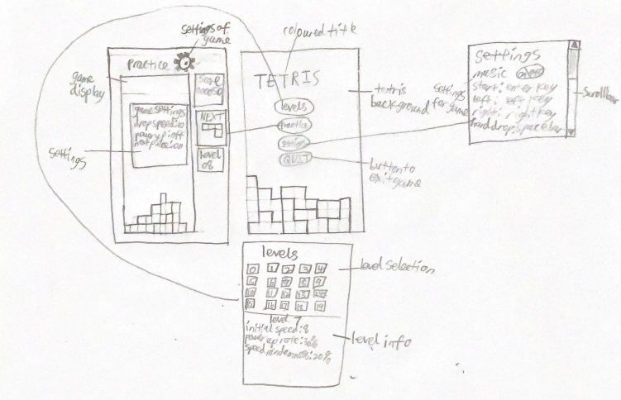

Idea 2

Another idea is to make a 2D platformer game which can help improve the hand to eye coordination and problem solving skills of users. These skills are important skillsets because problem solving skills can help users react to scenarios better and the hand to eye coordination skills can help the user complete physical tasks faster. In this platformer game, the user must overcome multiple obstacles, such as hard platforming, puzzle rooms or armed enemies, in order to get to the end goal. To get to the end of each level, the user must use their available resources, such as powerups or collectables, and problem solving skills to solve problems in each level. Usually 2D platformer games such as Super Mario Bros 3 are really popular because most of the users enjoy the games. This means the 2D platformer idea solves the problem since it is enjoyable to most users and it improves important skillsets that are used everyday.

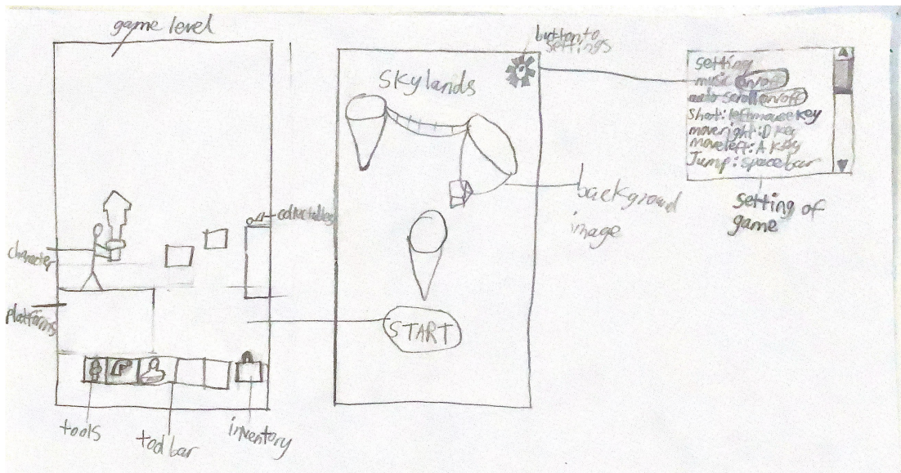

Idea 3

The last solution is to make a game similar to auto chess. When the game starts, the user is given a budget to buy different types of troops they want and then the user place them on the battle field. Once the round starts, the user’s team will auto battle the enemy team until one side wins. During each round, obstacles or powerups can also be added to make the game more entertaining. Usually the user needs to use their strategic thinking skills as well as problem solving skills to try and find the best combination of placements for each troop to win each round. The concept of auto chess games is designed to allow users to improve their strategic thinking skills by forcing them to react to multiple scenarios in the game. In addition to the game improving the strategical thinking of users, the game has an average rating of 4.1/5 which means this idea can solve the problem if it is implemented.

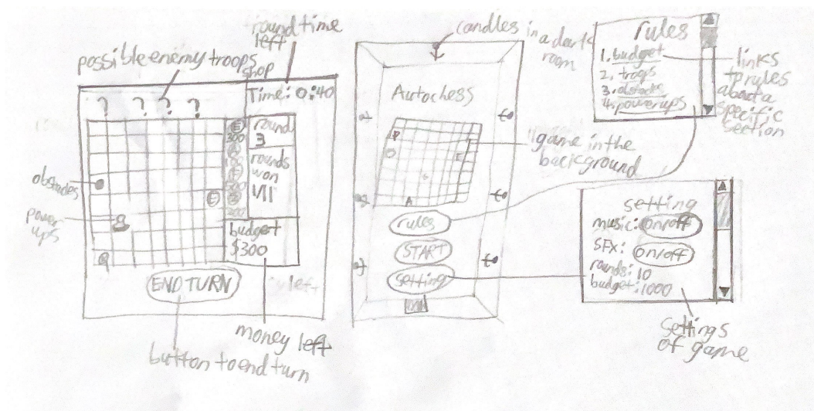

### Selection of an Idea (1 page max)

I have decided to choose the idea of making a game similar to the 1984 classic Tetris game. I chose this idea because Tetris is a popular game that many people find entertaining to play and the game is also able to allow the users to improve multiple skills such as faster reaction times or better spatial awareness. When compared to the two other game ideas, the Tetris game is considered to be the better option due to the fact that Tetris helps the user improve more essential skillsets. The main skillsets the 2D platformer game intends to help the users improve are hand to eye coordination and problem solving skills, the auto chess game idea intends to improve the strategic thinking and problem solving skills of the users, while Tetris focuses on the reaction time, spatial awareness, and problem solving skills of the users. If the auto chess and 2D platformer games were created, this would mean that I would have to spend a lot of time on the graphics or UI of the game due to the fact that there are a lot of characters and items that need to be implemented into the game. However, Tetris doesn’t require much graphical design when compared to the two other games because Tetris has less unique objects and the concept of the game allows most objects to be able to be reused. This means that if Tetris is chosen as my project idea, there would be more time focused on the development rather than the visual aspects of the game. This would allow the final game to be better and more finished since there is more time to add additional features as well as test and fix any errors in the game. Since there are less unique objects in Tetris, this means there would be less code required and as a result, the final product would be able to run more smoothly. This means that by choosing Tetris as the project idea, the users are more likely to be able to run the game smoothly and be entertained.

### Define Boundaries for the Software (half page max)

The boundaries for the software defines the limits of the system or project. By determining the boundaries, what is and isn’t part of the system is also determined. Items that are not part of the system but influences the system are parts of the environment. Examples of items in the environment that influences the system includes input devices such as mouse and keyboard. In the input devices, only some key presses such as left click in the mouse influence the system while other key presses such as the alt key on the keyboard has no effect on the system. This means that some key presses or the keys that create no effect on the system are outside the boundaries of the system while the other keys that creates a response in the system are included in the boundaries. In order for items in the environment to influence the system, there has to be an interface which acts as a boundary between the system and the environment. An example of an interface in the current project includes having a monitor that outputs information that is created from the data inputted by the input devices. In addition to required interfaces, some other limitations or boundaries of the system can include requiring certain device specifications in order to run the game smoothly, having errors in the game because of the limited time given to create the project, and the software isn’t compatible with every device. By defining the boundaries for the software, the client is able to have realistic expectations of the limitations of the final product.

### Preliminary Timeline (gantt chart)

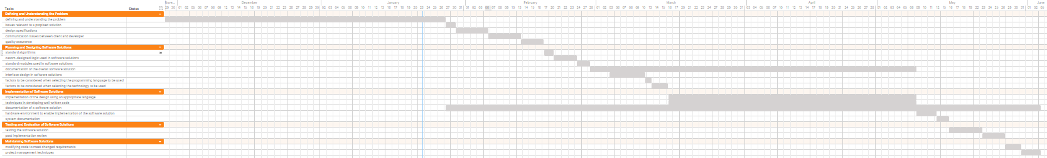

## Issues relevant to a proposed solution

### Determine if an existing solution can be used (3 pages max)

List comparable existing software solutions

There are many existing solutions on the internet I can use to help create my game. This is because my game idea is based off the concept of the classic Tetris game made in 1984 and since then, there has also been many other games made from the idea of classic Tetris. Some examples of the games or existing solutions I can use to help me are the official Tetris game made by Alexey Pajitnov in 1984, Tetris made by Atari Games in 1989, Super Tetris made by Spectrum HoloByte in 1994, Sega Tetris made by Sega in 1999, Tetris Party made by Tetris Online, Inc. in 2008, Tetris Effect made by Monstars Inc., Resonair, and Stage Games in 2018, and Tetris 99 made by Arika in 2019. All of these games are based off the main concepts of Tetris but have additional features that distinguishes them from the original classic 1984 Tetris game. For example, Tetris starts adding garbage or blocks not placed by the player as the levels increases, the game Super Tetris features powerups that can assist the players, Sega Tetris presents a battle mode where the player can attack their opponents by line clearing, Tetris party allows players to play multiple modes such as clear a certain amount of lines, or guide a piece through a vertical obstacle course, Tetris Effect adds a zone mechanic that is filled up by line clears and when activated, gravity stops for up to 20 seconds and during that time, all the line clears are pushed to the bottom until the zone time is over, and Tetris 99 is a battle royale game where you can send garbage to other players through line clearing.

Licencing considerations

However, even though there’re multiple existing solutions that is similar to my idea, the code of most solutions can’t directly be used in my project because usually the authors have put software licensing on their game. Most Tetris games like Tetris Effect have an end user license agreement(EULA) on their games where the player or end user has to agree to the license agreement in order to use the game. This means that the code of each game isn’t publicly released since most Tetris games have an end user license agreement instead of a public domain license. In addition to the type of software license each game has, the game usually also needs to be purchased. Since the project has no budget, this means that the only way to try and replicate the required features from the licensed games is to find online gameplay and try to reverse engineer the code. In addition to the end user license agreement on most Tetris games, The Tetris Company also holds the trademark of Tetris which means that game authors can only make Tetris games by agreeing to a license with them. Usually, the license will cost thousands of dollars which means that buying a license isn’t feasible for the project due to the fact that there is no budget to use. This means that when creating the game, The Tetris Company’s version of Tetris should be avoided.

Customisation options for existing solutions

The defining features of Tetris as defined by The Tetris Company are the tetrominoes have an official colour for each shape, there is a 40 by 10 grid where half the grid is hidden and the other half is visible, the super rotation system is used, the hold piece feature is used, and the 7 bag random generator system is used. This also means that when reverse engineering the code in Tetris games, the features have to be changed so that the official Tetris guidelines are avoided to avoid copyright issues. Some possible examples of customisation options that can be used in the project are using polyominoes instead of tetrominoes as shapes, dropping powerups instead of having them spawn randomly at the bottom, and using a different point system where lines cleared, the height of the stack, and time since the start of the round can influence the number of points gained.

Cost-effectiveness

Currently, the project has no budget and the only resources provided are free software editing tools, such as Python IDE, and websites and tutorials that can be accessed through the internet. This means that the code of actual Tetris games can’t be accessed since the games can’t be accessed with the current budget or resources. Instead, the only other option is to find online gameplay videos and reverse engineer the mechanics into the current game that is being developed. Most gameplay videos are usually easy to find due to the large popularity of the official Tetris games. By watching the online videos, it also means that all the features of the game can quickly be recognised rather than having to spend a long time trying to learn the controls if the actual game is purchased. This means that finding online videos to help recreate the required features in the project is a more cost-effective and more productive method than buying the official games.

Social and ethical considerations

During the development of the game, the social and ethical considerations need to be acknowledged in order to make the final product as best as possible. The three main social and ethical considerations are changing nature of work for users, effects on the level of employment, and effects on the public. By considering the changing nature of work for users, the effect the final product has on the users should also be considered. When the customisations options from existing solutions are added to the current project, the final product will be able to be more entertaining due to the fact that there is more mechanisms within the game than before. In addition to making the game more entertaining, these mechanisms can also help the users develop their skill sets since their reaction time can be improved when they experience the new game features, and their pattern matching and strategy skills need to be improved if they want to achieve a good result in the final version of the game. This means that by using the modified features inspired by the existing solutions, the final product can achieve the aim of the project more efficiently than before. The consideration of effects on the level of employment considers whether or not the project will affect the employment of people. Due to the fact that the final project is intended to be single player only, this means that there won’t be servers that need to be maintained. The game is also intended to be a small project so it also means that additional developers aren’t required in order for this project to be completed or maintained. This means that the end product shouldn’t have an affect on the level of employment. The consideration of effects on the public considers how the community will be affected as well as the opinions the users have towards the product. The final product should have a positive effect on the public community because users that are interested in the software can play the game enjoyably as well as get better at skill sets and the final product doesn’t replace any old systems so uninterested users can resort to the software they were using before. However, the customisation options inspired by existing solutions might make the final product a good software for focusing on practising certain skill sets, like getting faster reaction time or develop better pattern matching skills, and users might be reluctant to immediately switch the software they were using to improve these skills due to the unfamiliarity as well as the game covers on multiple skill sets instead of allowing the user to focus on a specific skill.

Conclusion

Therefore, by watching online gameplay of various official Tetris games, the required features from the games can be reverse engineered into the project. Modification of the game mechanic is also required to avoid copyright issues from The Tetris Company. By making customisations to the game features, the final product can allow users to improve skill sets as well as be entertained which means the final version of the game will achieve the aim better than before.

### Select and justify an appropriate software development approach (1 page max)

There are 6 main types of software development approaches: the structured approach, agile approach, prototyping, rapid applications development(RAD), the end user approach, and a combination of software development approaches.

Structured approach

The structured approach is a step-by-step approach where one step must be completed before progressing to the next step. When this approach is used, there is usually a large budget and a long timeframe allocated towards the project. If the structured approach is used and an error that initiated from the earlier stage is left untouched, it will cost more to repair the damage in the later stages. This means that developers need to ensure there are no errors when they set up the requirements and specifications for the project.

Agile approach

In the agile approach, the development team aims to get a working solution to the market quickly and working versions of the software are regularly delivered. This approach also removes the need for planning documentation. Usually, the agile approach is used if there is a small team of developers, a low budget and a limited timeframe allocated to the project.

Prototyping

In the prototyping method, prototypes are made to progressively refine user requirements. In this approach, after the initial problem is defined and understood, a prototype is made by the developers and the client evaluates the prototype which allows the development team to improve the prototype. This cycle continues until the client confirms the user requirements are met by the prototype and the prototype is then implemented into the system. Usually, the prototype approach is used when the user requirements for the project is not fully known.

RAD

The RAD approach aims to reduce the development time so that the requirements for the system can be quickly met and implemented. This approach uses 4th generation languages, standard APIs, CASE tools and other software to help develop the project. However, the RAD approach might create a less usable, efficient and detailed product than a product created using the other methods.

End user approach

In the end user approach, developers create products by customising other applications using automatic code generating devices. Through this approach, developers can maintain the software at a low cost, but the resulting product will be less efficient due to the nature of the original solution.

Selection and justification

The best approach to choose for the current project is a combination of the structured and agile approach where the structured approach is used for the documentation and the agile approach is used for the development of the software. By using the structured approach for the documentation, the algorithms that are designed can be more thorough and the design features can be well thought out. This means there will be less errors and bugs in the final solution. By using the agile approach, the software project can be ensured to be finished within the timeframe given. If there is more time remaining after the initial version is finished, additional features can be added to the final software.

## Design specifications

### list of specifications of the software (1 page max)

Functionality of the software

In order to create a successful software that meets the aim of the project, the specific details of how the system is going to function must be mentioned. By the end of the project, the finished software should feature functions that allows the user interface to be displayed smoothly at a minimum of 30 frames per second, allows the game mechanics, such as polyominoes falling at a constant rate, to run accurately with no errors, constantly updates the score system accurately whenever required, makes sure the randomised polyominoes generating system is fully functional, and ensures the system correctly responds to the input of the users with a maximum delay of 0.1 seconds.

Non-functional requirements

After ensuring the functional requirements of the software are considered when designing the software, the non-functional requirements should be recognised. The non-functional requirements are the functions or features of the software that increase the user satisfaction but are not necessary for the software to operate. Some examples of the features in the software that intends to focus on improving the user expectations are having a high score system where the user can see their best score achievements, giving the user a chance to toggle the settings of the game, and giving the user a tutorial to help them learn and be able to use the software easier.

Interactions with the environment

The environment in a system is anything that isn’t included in the system but interacts with the system. In order for the software to perform the functions that fit the functional and non-functional requirements, the system has to receive the inputs from the environment that influences which functions are executed. In this computer system the user controls what inputs are inputted through their input hardware devices like keyboards and mouses. After the software system performs the function that is requested by the user’s inputs, the software outputs the result of the function through output devices like monitors and speakers.

Performance of the software

In addition to considering the different functions of the finished system, the performance of the software must also be acknowledged when listing the software specifications. In order for the software to be able to satisfy the user’s needs, the system’s performance must be sufficient enough for the software to run smoothly. If the performance of the software is insufficient, then the system’s output will be slow and delayed, the frames per second will drop which will result in rough gameplay, and the software might unexpectedly crash. These results are undesirable as they can ruin the user’s experience of the software so the performance of the system should be ensured to be sufficient enough for the user to use. In addition, the program should also be able to respond to the users quickly due to the main game being based around a reaction time game. The main performance requirements of the software are having a quick speed of execution and response, ensuring there are no errors in the code of the system, and making sure that there is enough memory and storage for the software to use. The main methods of ensuring these performance requirements are met are using minimal code in the software usually by removing redundant and unnecessary code, and making sure the minimum software and hardware requirements of the software are met by the user’s device.

### Proposed architecture of the programmed solution (2 pages max)

The data types

Two common data type that could be used are integers and floating points. In the software, the system could use integers to display information, like the high score, to the user. In addition the display of the system, integers and floating points might also be used to calculate the value of variables. An example of this is the current drop speed formula in the final software might use floating points or integers to calculate the current drop speed. String data types could also be used by the system to communicate to the user. An example of string data being used in the final solution is the settings menu which displays strings of characters that allow the user to understand what the different settings are. Boolean data might also be used by the system to record the status of different variables such as the status of whether a certain key is held down or not.

The data structure

A data structure is a format that allows data to be able to be organised, processed, stored, and retrieved. The two most common types of data structures are lists and multi-dimensional arrays. In the final solution, the system can use lists and multi-dimensional arrays to store data so the software can find the required data easier when performing functions. In the software, lists can be used to store different scores of the user, and multi-dimensional arrays can be used to store the different rotation positions of each polyomino shape where the columns and rows are polyomino shapes and polyomino rotation positions.

Algorithms

Algorithms are methods of solutions that are designed to solve a problem and they describe the steps required to perform the methods. The algorithms that will later be created to help the developers produce the software should outline the different steps required to perform certain functions. Each algorithm should be focused on one unique function and the algorithm should specify the variables required, the different control structures, as well as the sequential order of the actions required.

Variables

A variable is a value that can change depending on the conditions in the software. Usually, variables are used when the data stored in the variables are going to change multiple times. In the final software, variables will be commonly used. This is because the system will use variables to store a lot of the constantly changing data such as the high score or the current lines cleared. The software can also use these variables to help the system perform various functions. For example, the system might use the current lines cleared variable in the function used to calculate and update the current score of the user.

Software development approach

From the 6 options of the structured approach, the agile approach, the prototyping approach, the rapid applications development approach, the end user approach, and a combination of software development approaches, the development team has decided to choose a combination of the structured and agile approach. This is mainly due to the lack of budget available as well as the limited timeframe given to create the software. In addition to the lack of resources, using the structured approach for the documentation can help minimise the errors that will occur and using the agile approach for the development of the software can ensure the project is completed by the deadline.

Quality assurance

During the planning process of the project, the quality assurance of the final solution should be considered. The quality assurance of a system is the systematic efforts that are required so the software can meet user expectations. The discussion about the quality assurance of the software should describe the processes that will be used to guarantee a quality product, define the criteria that will be used to judge the quality of this software project, explain the criteria used to determine the quality of the final solution, and the steps required to ensure the ongoing assurance of quality in your software solution.

Modelling the system

Before starting development on the software, the developers must model the system so they understand what all the main functions of the final software are. After understanding how the main functions in the system work with each other, the developers should also evaluate how well the final software will meet the users’ needs. After the evaluation, the developers should remodel the system until they believe the final software will satisfy the user expectations. Some examples of ways the developers can model the system are writing algorithms to describe the logic in specific functions, listing standard modules that can be used in the final software, and designing the system’s user interface.

Documentation

Throughout the development of the system, developers are required to write developer documentation so other developers who work on the development of the software can understand how certain functions works. By writing documentation, teams of developers are able to work efficiently and accurately and the maintenance developers are able to maintain the software easier. By the end of the project, the developer documentation should include what intrinsic documentation, such as useful variable names and indentation, were used, how the logbook details how the code was implemented, how the code increases the maintainability of the solution, what the main lines of code means in the final solution, how error debugging tools were used to find and correct errors in the code, and refining the planning diagrams, such as algorithms, data dictionaries, IPO chart, data flow diagrams, structure charts, context diagrams, and flowcharts, to reflect the final solution. In addition to developer documentation, the developers also need to add user documentation to help the users understand how to use the software. The user documentation should include the user manual that will assist in helping the user learn how to use the system, the installation guide that will help the users learn how to install the system, and online help which will help the user use the system through the final software.

### The considerations needed to be taken in regard to the user in the development of this software solution (2 pages max)

Interface design

When designing the final software, the developers must consider the design of the user interface of the system. The user interface is the way the system communicates with the user. This means that making sure the user interface is as best as possible is essential to ensure user satisfaction. The main features that should be considered when designing the user interface are the audience, screen size, online help, consistency of design, social and ethical issues, design elements, current industry standards, and practices and inclusivity. To assist the developers with creating the user interface, the developers can create storyboards to help themselves visualise what their current idea of the user interface would look like. From the drawn storyboard of the planned user interface, the developers can also decide on which features aren’t intended and change it until they are satisfied with the design. In addition to storyboards, the developers can also implement the design on a user interface design software where they can test all the different linking features as well as making sure they are happy with the final design of the user interface.

Appropriate messages

When designing the software, the developers need to consider how the software will communicate with the users. One common way of communication is through pop up text boxes that will display a message for the message to read. Usually pop up text boxes are used when the system is trying to tell the user an important message such as what error has occurred or what are the controls of the system. When designing the pop up text boxes, the wording of the message should be phrased in a way so users can easily understand the message, design features should be used to make it look more aesthetically pleasing to the users, and design features that already exist in other popular software the user uses, such as next buttons that proceeds to the next screen or the close window icon that closes the text box, should also be included.

Appropriate icons

Icons will be used throughout the final software frequently with the most common placement being icons on buttons that links to other screens or pop up text boxes. Due to this common placement, most users will see the icons when they use the software because they need to use the buttons to navigate around the software. This means that the design of icons within the software is also another important factor developers need to consider during the design process. When designing and developing the icons for the software, developers should consider the use of the icon in the software. For example, the settings menu button could have an icon of a gear to indicate the button leads to the settings page. After the icon is designed, the developers should ensure the final icon will help the users use the system.

Relevant data formats for display

The data formats for display need to be considered so the system can display the required data through the user interface to the users. In this game, the main displaying data formats that are used are text, image, and audio. This means the developers also need to consider what hardware needs to be required so the data within each data formats can be displayed. The text and image data formats can be displayed through laptops and monitors while the audio data format can be displayed through speakers and headphones.

Ergonomics

Ergonomics is the study of the relationship between people and their work environment. When considering software ergonomics, usually user needs, interface design, user support, and usability testing are identified. When discussing the user needs, usually their work routine and preferences are mentioned so the ergonomics can be considered. The users of the current system will use the software on a desk with their preferences being the features used in the other software they use. After the user needs is determined, the user interface should be designed. The user interface is important when considering software ergonomics because the user interface is how the user communicates with the system. In addition to interface design, usability testing should also be performed throughout the design process so the final design can be ensured to be ergonomically sound. User support, which includes the installation guide, help manual, and online help, should also be designed in the design process. By creating user support within the system, the developers can ensure the ergonomics of the users are improved by allowing them to use the system more easily and efficiently.

Relevance to the environment

When discussing the environment of the system, developers should consider the user’s computer configuration and it will interact with the final software. Computer configuration is the arrangement of hardware and software in a computer system. When the users use the final system, how efficiently the system runs depends on whether or not their computer system is compatible with the software. This means that when designing the software, developers should try to design the system to be able to be ran smoothly on most computer systems. Developers should also include the minimum hardware and software requirements in the installation guide so the users can know if their computer system can run the software or not.

Social and ethical issues

Developers need to consider the social and ethical issues that can affect the users of the system. These issues are the quality of the software, privacy, security, and inclusivity of the users. The quality of the final software will impact the users since the quality will determine how efficiently the system will run. If the quality of the system is poor, then the user’s satisfaction will be low which means the developers need to improve the quality of the software whenever possible. Usually, the developers will ensure the quality of the final product will satisfy the users through the quality assurance process in the designing stage. When the users use the software, the developer needs to make sure the users’ privacy is protected. This means that the software shouldn’t use the users’ personal information without their permission. One method developers can use to prevent this is by making the users agree to the terms and conditions before using the software. The terms and conditions will inform the users what data collected from the users will be used and what will be done with the data. In addition to using the terms and conditions, developers can also give the users the option of whether or not they want to give personal information to the system or not rather than forcing the users to give up their personal details. Another common issue that must be considered is security. The developers must ensure their final product that is released doesn’t contain any malware or viruses that can harm the users’ devices. In order to do this, the developers should regularly update their anti-virus software, scan emails and files for malware, use firewalls and other security mechanisms, and scan the software for viruses and malware before distribution. When designing the software, the inclusivity of users should also be considered. Inclusive software aims to be usable by all types of users, especially people with disabilities, different backgrounds, and economic issues. This means the developers should consider these factors so the software can be more inclusive.

### Demonstrate the algorithm specifications to be used and identify a range of algorithmic logic that will be required in your solution

Algorithms are a step by step procedure that is made to solve a certain problem and developers implement the solution based on the algorithms they’ve made. There are two main methods of developing algorithms: pseudocode and flowcharts.

Pseudocode

Pseudocode is an artificial language that helps developers develop algorithms that are later used in their solution. The language uses English like statements with a predefined set of rules of structures and keywords to describe the algorithm.

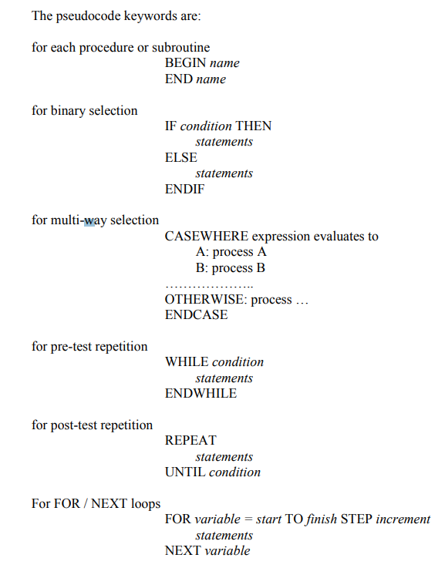

When writing pseudocode, developers need to include the beginning and the end so the algorithm can indicate what is in the function. Developers can also choose to use different control structures such as binary selection, pre-test repetition, and for loops. Usually, specific control structures are used for certain scenarios. For examples, binary selection is usually used for making decisions that only have two options.

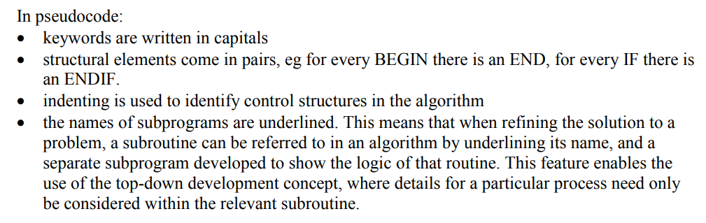

Flowcharts

Unlike pseudocode, flowcharts are a diagrammatic method of representing algorithms where the diagram is read from top to bottom and left to right.

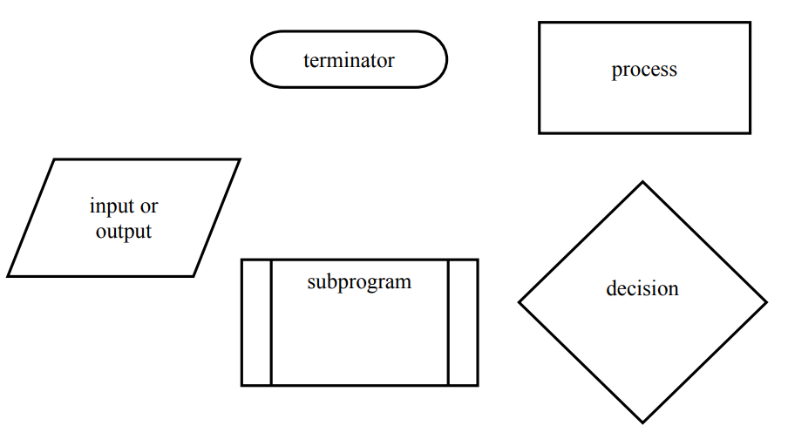

In flowcharts, these symbols are usually used to represent the different control structures and actions in an algorithm. Instead of being read from top to bottom, instead the flow of the algorithm is indicated through the arrow lines that connect two processes or control structures.

### preliminary data dictionary

|  |  |  |  |  |  |
| --- | --- | --- | --- | --- | --- |
| **variables** | **Data type/structures** | **Format** | **Size** | **Description** | **Example** |
| Unique Polyomino rotations | 2-dimensional array | [‘X’,’X’,’X’], [‘X’,’X’,’X’], [‘X’,’X’,’X’] | 1000 | The 2-dimensional array includes the shapes of the unique rotation positions of each polyomino | 4PieceShape=[[‘1-2-3-6’, ‘2-5-6-10’, ‘2-5-6-7’, ‘2-6-7-10’], [‘2-6-10-14’, ‘9-10-11-12’], [‘1-2-3-6-10’, ‘4-6-7-8-12’, ‘7-11-14-15-16’, ‘5-9-10-11-13’]] |
| High score | List | ‘X’,’X’,’X’ | 200 | The high score list contains all the previous scores of the player in order from highest to lowest | highScore=[‘674284’, ‘562943’, ‘238594’] |
| drop speed | float | XX.XX | 5 | The drop speed is the speed the polyominoes will drop or fall at | dropSpeed=1.67 |
| Random Number | Integer | XX | 2 | A random nember between the given range is selected | randomNumber=7 |
| Beat level | Boolean | X | 5 | States whether the level has been beaten by the player | beatLevel=True |
| Error message | string | XXXXX | 200 | States the error that has occurred in the system | Error message= ”Error 502 code has occurred because the servers is under maintenance” |

### Create preliminary context diagram, IPO, Structure Chart and System Flowcharts for your proposed software solution

Context diagram

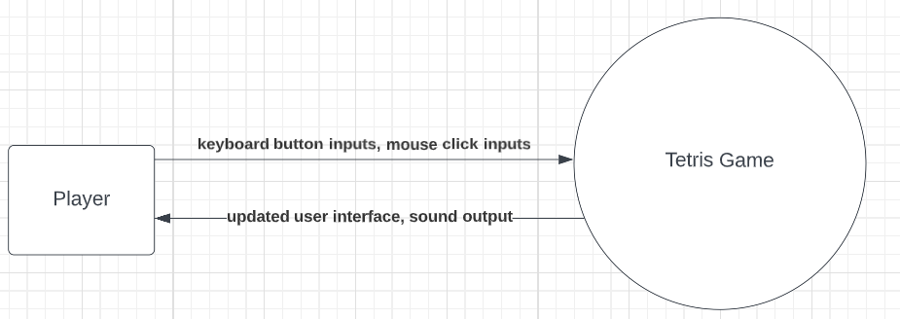

IPO chart

|  |  |  |
| --- | --- | --- |
| Input | Process | Output |
| Rotation key status  Rotation count  Current type of polyomino  Current rotation position  Next rotation position  Filled grid positions | 1. Check rotation key status 2. if rotation key is pressed, next rotation grid positions is not filled, and set rotation count is set to 0  * get current type of polyomino * get current rotation position * get next rotation positions * update rotation position * update polyomino grid position * set rotation count to 1  1. if rotation key is not pressed  * set rotation count to 0 | New current rotation position  New next rotation position  New polyomino grid position  Updated user interface |
| Down key status  Level drop speed  Polyomino contact status  Current polyomino grid position  Filled grid positions | 1. Check down key status 2. If down key is pressed  * Check polyomino contact status * If polyomino contact status is set to false  1. Set drop speed to a higher drop speed 2. Repeat move polyomino down 1 grid until down key is not pressed or polyomino contact status is set to true 3. If down key is not pressed  * Check polyomino contact status * If polyomino contact status is set to false  1. Set drop speed to level drop speed 2. Move polyomino down 1 grid Repeat move polyomino down 1 grid until down key is pressed or polyomino contact status is set to true | New drop speed  New polyomino grid position  Updated user interface |
| List of available power ups  List of available polyominoes  List of next pieces  number of available power ups  number of available polyominoes  Level percentage chance of power ups | 1. Get list of available power ups, list of available polyominoes, list of next pieces, number of available power ups, number of available polyominoes, and level percentage chance of power ups 2. generate a random number called randomNumber1 between 1 and 100 3. if randomNumber1 is between 1 and percentage chance of powerups  * generate a random number between 1 and the number of available power ups * add power up to next pieces list  1. else  * generate a random number between 1 and the number of available polyominoes * add polyomino to next pieces list  1. if active piece on grid is set to zero  * add first item of next pieces list to the grid * remove the first item of the next pieces list from the list * make every position of each item advance one in the next pieces list | New polyomino/power up in the grid  Updated user interface |

Structure chart

Tetris match

Level details

Open/update Tetris match page

Select level

Display Level details

Level details

Pre-select level

Level selection page

update practice match page

Current settings

New settings

Open practice settings page

Practice settings

Default match settings

Default settings

Open tutorial

Open/update practice match page

Current settings

Practice match

current settings

Open settings menu

Level selection

Settings menus

Game system

tutorial

Tetris match



Tetris match

Win condition

Win

lose condition

Open lose page

Lose

Open win page

Updated object position

Updated object position

Updated object position

Updated score

New Line clears

Level drop speed

Pieces details

Add piece to grid

Available pieces

Random piece generating system

Power ups/polyominoes

lose condition

Lose line status

Check lose condition

Win condition

Current score

Soft drop

Rotation

Move left/right

Scoring system

Gravity

Check win condition

System flowchart

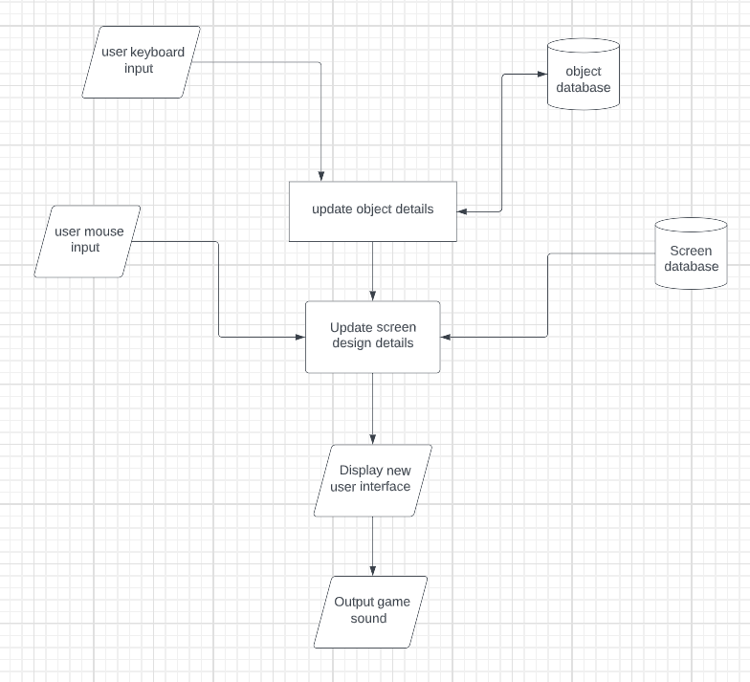

## Communication issues between client and developer

### Explain how you will consult with the client throughout the project, and include and plan for inclusion of the client’s perspective and feedback (2 pages max)

Communication with clients

When creating a software product, the developers need to consider the user needs during the whole development process. This means that throughout all the stages of the software development cycle, the developers should regularly communicate with the clients to ensure the final software satisfies the requirements set by the users. Some common communication methods developers can use includes surveys, interviews, memos, and emails.

Surveys

Surveys are one way developers can collect feedback from clients. In this method, clients fill out questions about the software project in the form that is sent by the developers who will receive the feedback when the form is submitted. Usually, the feedback collected from surveys are the clients’ broad opinions about the software. This means that when using the feedback from the surveys to improve the software product, developers could struggle in meeting the user requirements due to the vagueness of the feedback.

Interviews

Another similar method of allowing developers to communicate with clients are interviews where instead of asking the users to fill out a form, the developer meets with the clients in person and asks them questions. By conducting an in real life meeting with the clients, the developers can make sure the users understand what the questions means, and the developers can ask more specific and more detailed questions. Due to more specific questions being asked, developers are able to receive more detailed feedback about their software product.

Memos

Unlike surveys and interviews which gathers feedback from answered questions, memos are messages that are sent to a group of people. In response to the memo sent by the developer, the client can choose to send a feedback memo that gives constructive feedback on the topic of the original memo. If developers used memos to communicate the software product scenario, the clients would be able to easily express their thoughts on the current scenario through feedback memos. However, not everyone is guaranteed to send feedback memos and the feedback in the feedback memos might not be useful to the developers.

Emails

Similar to memos, emails are online messages sent between two people but there are usually multiple messages sent by each person. Developers can use emails to communicate with users online and create conversations about the software product. However, not everyone will respond to the emails immediately so online email conversations could take a long time to finish.

Selection of communication methods

Although all types of communication can be used, the most effective communication method for developers to use are interviews. This is because the developers can interview the clients about their opinions of specific parts of the software, they can gather useful, specific feedback, and interviews can be quickly finished. When developers use surveys and memos, the feedback received would be less detailed and useful, and developers would have to spend a long time gathering detailed feedback when using emails.

Inclusion of client perspective and feedback

When communicating with users, the developers must cover certain topics so they can gather useful user feedback which can help ensure the final software is as optimal as possible. Some examples of topics that need to be covered when communicating with clients includes the current progress of the software project, the clients’ opinions on the functions and design of the current software, the software’s progress towards meeting the user needs and requirements, and any suggestions or recommendations to improve the software. After the client perspective and feedback is collected and considered, developers should change their current software to include the suggestions so the user satisfaction of the final product can be improved. In addition to implementing the recommendations in the software, the developers should also consider their discussions with the clients during the future development of the software.

### Explain how you will involve and empower the client in the development process (1 page max)

During the designing phase of the development process, communication with the clients can allow developers to gather useful information that will improve the design of the software. Developers can use the collected users’ feedback and perspective to improve multiple areas of development which can include using the users’ perspective to document the initial problem that needs to be solved, using the users’ opinions to help select which software idea should be created, using the users’ perspective to help identify the functionality and requirements of the final software, and using the users’ feedback to improve the design of software. When the clients are satisfied with the design of the software, developers can start creating the software system. After the developers have created the first version of the software product, they can also communicate with the users to discuss the features of the software if the developers believe they still have time to implement an improved version of the software. If the developers decide to communicate with the clients, then the feedback of the clients can allow the final software to improve the user satisfaction as well as ensure the final software will meet the needs and requirements of the users.

### Document this communication and evaluate its effectiveness using a quantifiable measure. (1 page max)

1. Before the project began, I communicated with some teenagers and adults and we decided on the issue that needed to be solved. By communicating with the users, I was able to define the problem, start to draft the possible functionalities of the final software, and start to think of the different ideas or solutions that could solve the problem. This means my communication with the intended users before the project has been effective since it helped me to create and understand the purpose of the final software.
2. After I have defined the functionalities and selected an idea, I communicated to multiple clients through a presentation and the feedback I received was they were happy with the decisions I made in the project. Through the presentation of the initial sections of the project, I was able to confirm that so far the users also agree with the decisions I made so this communication method confirms the users will accept my solution to the problem which means I can continue to develop the project further.
3. Throughout the creation of the prototype of the software, I communicated with my clients to gather their opinions and feedback of each draft that was created. By collecting feedback on each draft, I was able to improve the drafts until the clients were happy. The first few drafts I created were a storyboard of the software which contained the main design features and the feedback helped me decide the placement of the software’s main design features. After the clients were happy with the storyboard, I created drafts on a prototyping software so the software’s smaller details like the font or text size can be decided by the client’s feedback. When the users are happy with the prototype, I am able to use the finalised prototype to help me create my user interface when I implement the software. Through this communication, I will also save a lot of time since creating storyboards drafts and prototype drafts will take less time than coding user interface drafts. This means I can find the best user interface in a few days through drawing storyboards and prototypes rather than spend weeks finding the best user interface by experimenting with the different possible user interfaces during the implementation of the software.

## Quality assurance

### Describe the processes that will be used to guarantee a quality product (1 page max)

Quality assurance are the set of processes that occur during the design process of the software. These processes should ensure the requirements and functionality of the software will be met when the final design of the system is implemented. Usually, the quality assurance process can ensure this by analysing the current system and giving feedback on the different sections of the system so the current software can be improved. By creating a quality assurance criteria, the developers can critically analyse their current system by comparing the features of the current system to their created quality assurance criteria. Since the quality assurance criteria contains all of the desired features that should be implemented in the final system, the developers are able to recognise the positive and negative features that are present in the current system when the quality assurance criteria is used to judge the current software. After using the quality assurance criteria to recognise the flaws of the current system, developers can start to think of solutions that will be implemented to remove these flaws. This means the quality assurance processes can be used to reduce the errors and bugs that could occur in the software, recognise the remove the security flaws present within the system, ensure the various functions and features of the software will always be functional, and improve the reliability of the system. As a result, the quality assurance processes will be able to improve the quality of the current system and provide the users with a confidence of the integrity of the final software. Usually, the quality assurance processes will regularly occur throughout the software project so developers can track their own progress in their project. These processes can also help developers realise what they are doing well and what is not working if the developers decide to compare the newest quality assurance results to the previous results.

### Define the criteria that will be used to judge the quality of this software project. (2 pages max)

The criteria

In order for the quality of the software to be able to be assessed, developers should create a list of criteria that can be used to judge the quality of the system. The list of criteria should also be used to help the programmer evaluate the system and find out which aspects of the software need to be improved. The list of criteria that judges the quality of the software should cover the topics of the software’s efficiency, integrity, reliability, usability, accuracy, maintainability, testability, and reusability.

Efficiency

The final software should be able to respond to the users’ inputs in less than 100 milliseconds, complete multiple functions consistently, and can be ran on the users’ computer systems. The software language that will be used to implement the software should also be carefully selected with approval from the clients. During the development phase, good programming techniques should be used and recorded into the documentation.

Integrity

The final system should be able to correctly use functions to output information. The files the system creates should only be stored in a specific location of the device’s storage rather than being stored in random locations. The specific location should be indicated by the user when the user installs the software.

Reliability

The system should have no major errors when the software is ran. All functions in the software should be able to be ran consistently with a maximum time of taking 0.1 seconds to output the function’s result. The final software should also be able to be compatible with the devices that are identified in the user requirements. When the system is finished, the software should also be maintained.

Usability

The design features of the design interface should be easy to use, and any client should be able to use the interface. Additionally, a tutorial on how to use or navigate the software should be provided as an option to the users. The shortcuts that are used in the other popular software systems the clients use should also be implemented into this system.

Accuracy

The functions of the software should be accurate and functional. When algorithms are created to help the developers create the functions, algorithms should be tested through desk checking, boundary testing, and pathway checking. When implementing the solution, internal and intrinsic documentation should be recorded.

Maintainability

When implementing the solution, internal and intrinsic documentation should be used to help the maintaining developers understand what each function means. When the software is maintained, functions should be altered to fix issues, documentation about the changes should continue to be recorded, and the altered functions should be thoroughly tested.

Testability

During the development and the maintainment of the software, the functions that were altered or created should be tested consistently. After the individual functions are tested, the entire software should also be tested. After the final software is tested, the software should be given to a client for them to use and test the system. After they have finished testing, any new issues that have occurred in the client testing should be fixed and the software should be tested by the client until there is no issues found.

Reusability

When implementing the software, developers should try to use modules or library routines that are available for use. During the development and maintenance stage, developers should also try to reuse code or functions.

### Explain the criteria for ‘quality’ and the steps required for ongoing assurance of quality in your software solution. (1 page max)

For the system to operate properly, the software should be able to output multiple functions consistently so the software can meet the user requirements. In addition to this, the functions’ purpose should always be achieved so the software can meet the users’ needs.

Usually, the functions’ functionality and accuracy can be guaranteed by creating and testing algorithms through desk checking, boundary testing, and pathway checking. By creating algorithms the final software can have less errors.

The software should also be tested regularly so the errors can be found and fixed easier and quicker than testing the software after implementation where the developers doesn’t know where the bugs are located. Regularly testing should allow developers to have more time to work on the features of the software. Acceptance testing should be conducted by the clients when the software is ready to be released. By conducting acceptance testing, developers can discover if the user requirements has been met or not and if the client isn’t happy when testing, then developers can change the software until the clients are satisfied with the system.

Developers should also ensure the system’s file storage is accurate which means the storage should be recorded in a file identified by the user rather than being spread over the whole computer. This should happen so the system won’t overwrite other files of the users and other software systems won’t overwrite the files of this software. Through this, functions of the software can be accurately executed. The file storage of the system can be ensured to be correct through software testing.

To increase the users’ satisfaction, the developer should add shortcuts from other software into this system if the shortcut needs to be used. Usually, these shortcuts can be determined from the communication between the users and developers. The user satisfaction can also be increased by implementing the design features that are suggested by the clients. Usually, the design features should make the design interface easier for the clients to use and the recommended design features should be collected through the communication between developers and clients.

To help the software achieve the users’ needs, developers should communicate with clients to select and approve the software languages that will be used to implement the solution. By approving the language, clients will know or gain a perspective on the features and limitations of the final software.

The software should also be guaranteed to work with the users’ devices so the clients can enjoy and use the final software without any problems. Usually the compatibility of the software can be increased by having less performance issues, less redundant code, and accurate and operational functions in the system. One method of reducing the amount of performance issues and redundant code is using library routines and reusing code when developing or maintaining the software. This is a useful method because the library routines have already been perfected by other developers and the developers don’t need to waste time writing unnecessary code. This also means by using the library routines and reusing code, developers can spend more time developing the system further.

After the final software is released, the system must be maintained so the new user requirements can be met and the software can work for the new environment. Usually, the software is maintained by changing existing or adding new functions to meet the new user requirements. In order for the maintaining developers to modify the functions in the software, they must understand the purpose of each function. They can usually do this through the intrinsic and internal documentation recorded during the development of the software. The maintaining developers should also continue to write intrinsic and internal documentation so future developers can continue to maintain the software.

# Stage 2: Planning & Designing Software Solutions

## Standard Algorithms

### List and describe all standard logic to be used in the software solution (2 page max)

Generating a set of unique random numbers

This standard algorithm generates a randomly selected number in a range from 1 to 99. The final software will use this standard algorithm in the random piece generating system. In the random piece generating system, a number generates between 1 and 100 to decide what type of piece the next piece will be and the random number is generated again between 1 and the number of possible pieces that still can be chosen. The system will be used in all the levels of the game as well as the practice level. It is an important system since it will also control which pieces will be added onto the grid and which pieces will be controlled by the player.

Add the contents of an array of numbers

This standard algorithm adds all the numbers in an array of numbers. It does this by initially letting the total be 0 and then use a repeat until loop so each item in the array of numbers is added to the total and the final value will be the sum of the numbers in the array of numbers. The final software will need to have an array of numbers to display the statistics of how many pieces of each type of piece was spawned. The software will also display the total amount of pieces spawned when the user wins or loses so this standard algorithm will be used in the final software to add the contents of the array of numbers that represent the statistics of the spawned pieces.

Linear search when searching for top out

This standard algorithm searches a data set from beginning to end until it finds the item it is looking for. It does this by first finding the length of the data set, then it loops through every item in the data set starting at the beginning of the data set to check if the item matches or not. If the item matches what the algorithm is looking for, then the search is ended but if the item isn’t a match, then it keeps searching until there is no more items to search. The final software will use this standard algorithm to check if the spawn areas or blocks are being occupied by the uncontrolled pieces or blocks. If there are blocks in the area, then the player immediately loses. This function needs to be performed everytime a new piece is added which is frequent. This means that the function needs to not take up processing time. This means that using this standard algorithm will be more effective than looping through the whole list since there will be a lot of items to loop through if the whole list is looped while the standard algorithm stops immediately when a match is found.

## Custom-designed logic used in software solutions

### Demonstrate your solution in algorithm form

Algorithm 1-polyominoes falling mechanic

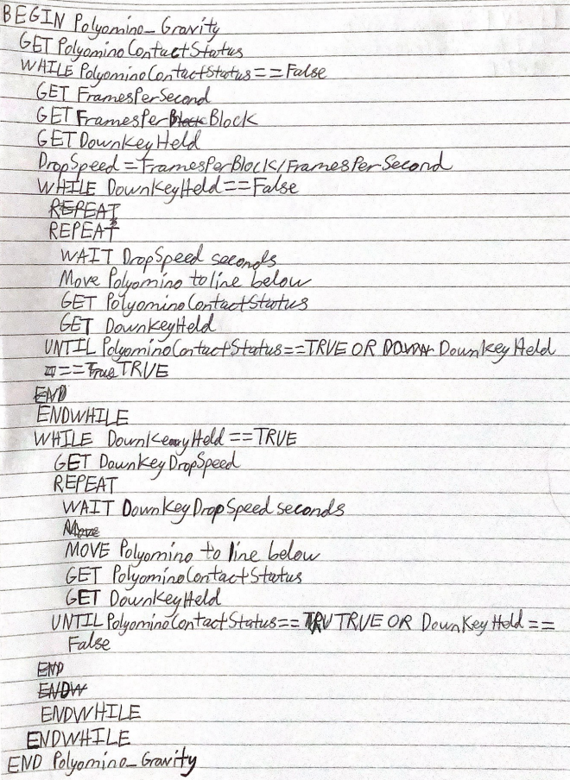

Algorithm 2-polyominoes rotating mechanic

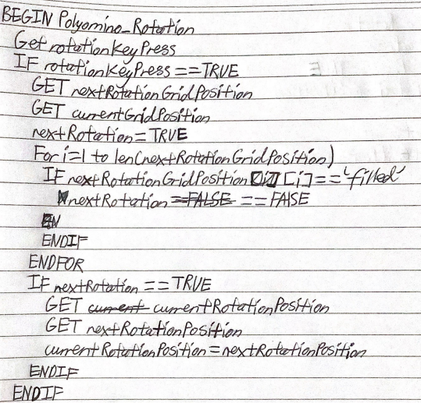

Algorithm 3-lightning power up mechanic

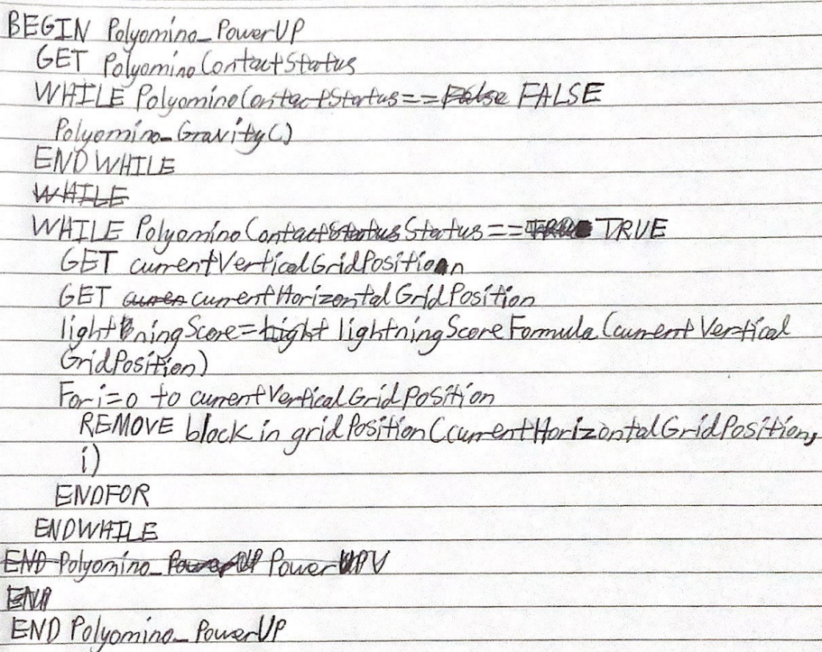

Flowchart 1-scoring system

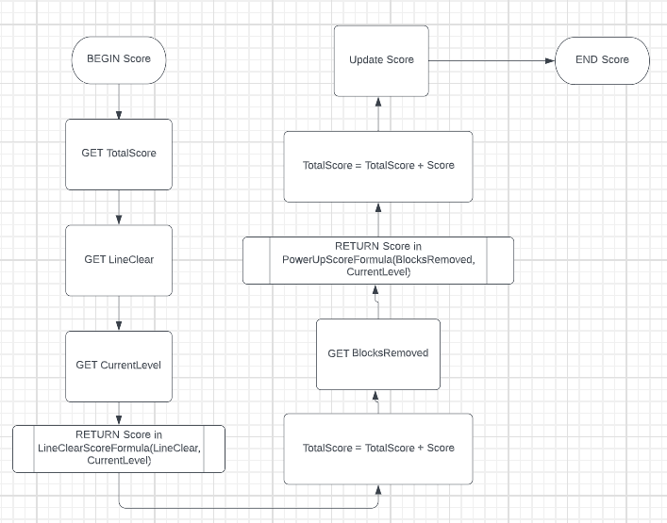

Flowchart 2-random generating system

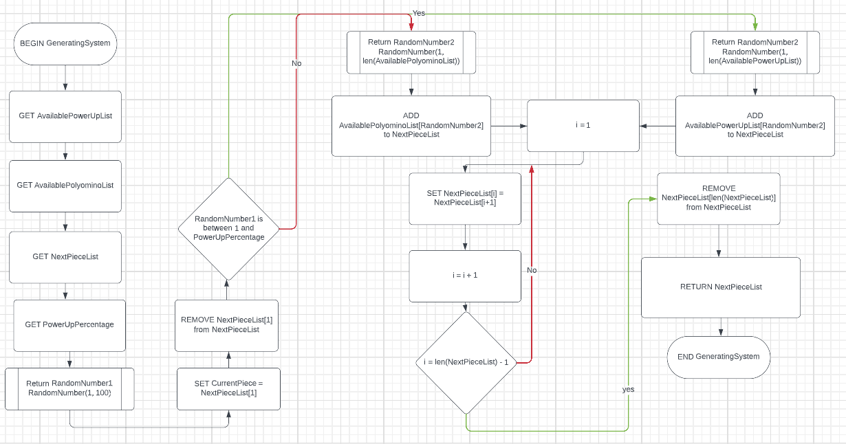

### Develop and document Test Data required to sufficiently test the algorithm solution.

Algorithm 1

Test DownKeyHeld = True and PolyominoContactStatus = True

Test DownKeyHeld = False and PolyominoContactStatus = True

Test DownKeyHeld = True and PolyominoContactStatus = False

Test DownKeyHeld = False and PolyominoContactStatus = False

Algorithm 2

rotationKeyPress = True

rotationKeyPress = False

nextRotationGridPosition[i] = ‘filled’

nextRotationGridPosition[i] = ‘not filled’

nextRotation = True

nextRotation = False

Algorithm 3

polyominoContactStatus = True

polyominoContactStatus = False

Flowchart 1

Nothing

Flowchart 2

RandomNumber1 is between 1 and PowerUpPercentage

RandomNumber1 = PowerUpPercentage

RandomNumber1 > PowerUpPercentage

i < len(NextPieceList) – 1

I = len(NextPieceList) - 1

### Where possible, desk check your algorithms. Note any changes made as a result.

The first draft of the polyomino gravity algorithm used binary selection and post-test repetition. However, when the algorithm was desk checked using pathway checking, it was found each action would only occur once in a sequential order instead of being repeated until the function ended, and the post-test repetition didn’t have the correct conditions that are required to end the loops. This means if the first draft was implemented into the final software, a logical error would occur as the result of the function is not intended. In the final version of the algorithm, the binary selection was changed to pre-test repetition so the actions could be continuously repeated until the function ended, and the ending requirements of the post-test repetition were modified to be more accurate.

Test DownKeyHeld = False and PolyominoContact = False/True

|  |  |  |  |  |
| --- | --- | --- | --- | --- |
| PolyominoContact | FramesPerSecond | FramesPerBlock | DownKeyHeld | DropSpeed |
| False | B | C | False | C/B |
| False |  |  | False |  |
| False |  |  | False |  |
| … |  |  | … |  |
| True |  |  | False |  |
| True |  |  | False |  |
| True |  |  | False |  |
| … |  |  | … |  |
| … |  |  | … |  |
| … |  |  | … |  |

Note: infinite loop/logic error

Test DownKeyHeld = False and PolyominoContact = True

|  |  |  |  |  |
| --- | --- | --- | --- | --- |
| PolyominoContact | FramesPerSecond | FramesPerBlock | DownKeyHeld | DropSpeed |
| True | B | C | False | C/B |

Test DownKeyHeld = False/True and PolyominoContact = False

|  |  |  |  |  |
| --- | --- | --- | --- | --- |
| PolyominoContact | FramesPerSecond | FramesPerBlock | DownKeyHeld | DropSpeed |
| False | B | C | True | C/B |
| False |  |  | True |  |
| False |  |  | True |  |
| … |  |  | … |  |
| False |  |  | False |  |
| False |  |  | False |  |
| False |  |  | False |  |
| … |  |  | … |  |
| False |  |  | True |  |
| False |  |  | True |  |
| False |  |  | True |  |

Note: infinite loop/logic error

Test DownKeyHeld = True and PolyominoContact = True

|  |  |  |  |  |
| --- | --- | --- | --- | --- |
| PolyominoContact | FramesPerSecond | FramesPerBlock | DownKeyHeld | DropSpeed |
| True | B | C | True | C/B |

Due to the nature of my algorithms constantly retrieving the variables from outside functions, it is hard to desk check my algorithms or flowcharts since there are multiple combinations of variable that need to be desk checked for each algorithm or flowchart.

## Standard modules used in software solutions

### Identify and justify one module in your software solution that might be more widely used. Discuss what would be required to implement it as a library routine (1 page max)

Widely used module

One module that might be widely used in the final software is the control keys module. This module will allow the users to be able to control the current piece on the field. In games where the user controls a character or object, the character is controlled through the different key presses or key inputs from the user. The software I am making is similar to these type of games where the users have to control objects or polyominoes to play the game. The user should only need to use the control keys module when there is a controllable piece on the screen so the module should only be active when the game in the software is ran. However, the software is designed so the user will spend most of their time playing the game when they use the software which means this module will be used constantly.

Library routine

An easy way to ensure the users can consistently use the control key module in the software is by making the module a library routine. A library routine is a debugged group of code that is designed to handle commonly used or occurring tasks. Library routines are stored in a program library so they can be used at any time by any program. By making the control key module, the software can use the code anytime the game in the system is ran. In order to convert the module into a library routine, the code needs to be transferred into a file in the library location and the library routine should be used when the code needs to be used in the software. Whenever the library routine is used, the user’s input needs to be transferred from the software to the library routine file so the library routine code can be executed.

### Identify and describe two library routines you are using from the source language or IDE. Describe what makes them effective routines to be used. (2 pages max)

Random generating number

The random generating number library routine generates a random number between two numbers that is specified by the developers. This routines will be used to determine the type of piece that is generated can be determined. The type of piece will determined through the random number that will determine if the piece is a polyomino or a power up and another random number that will determine the shape or function of the piece. In addition to being necessary for the system to work, the module will already be ensured to not have any errors and the code wouldn’t have to be rewritten by the developers. The library routine will also be able to reduce the redundant code in the final software.

Open image

The open image library routine allows the software to be able to open an image in the tkinter user interface. This module will be useful in helping the final software be developed since the final system needs to have a user interface that can display images to the user. Specifically, there will be different icons such as the different polyomino pieces displayed in the game of the software. Without this library routine, the final software can’t display the different aspects of the user interface to the clients. This library routine is also helpful because the code needed to open images doesn’t need to be created and perfected. This means the developers can save time by not making and testing the function, and the amount of code in the final code can be reduced.

## Documentation of the overall software solution

### Refine your Data Dictionary to document Class and method variables, broken down by class. Represent a range of data types. This should NOT be exhaustive of every variable in your program, but should show a range of data types to serve particular purposes.

Refined in stage 3

### Describe the implementation and use of at least one CASE tool during your development (1 page max)

There are many Computer Aided Software Engineering (CASE) tools that can be used to help developers implement their software program and test and evaluate the finished product. The main IDE I will use is the Integrated Development and Learning Environment (IDLE) Shell python Integrated Development Environment (IDE). By using this IDE, I was able to import library routines, uses syntax highlighting, use the IDE to debug the code when the software is run, and locate errors during the execution of the software. These tools are all built into the IDE in order to help the developers code the software more efficiently and accurately.

Library routines

The IDE will allow popular library routines to be able to be imported into a software file. This means that developers who use this feature can save time since they don’t have to waste time learning to recode an already existing feature. In this software project, many popular library routines such as the timer library routine or the random number generator library routine will be used. This means this case tool was able to help the developers in this software project save time during the implementation of the software. Some popular library routines such as the timer library routine can also be used to help developers test the final software. For example, if the developers wanted to benchmark the software to check if the response speed met the industry standards or not, they can use the timer library routine to test and measure what the system response speed is.

Syntax highlighting

During the implementation of the software, the IDLE Shell python IDE CASE tool will highlight or change the colour of certain words that is recognised by python as specific functions. Some examples include changing the colour of certain words to yellow so the developers know the line is seen by python as a data structure or function, the colour green is usually shown to represent strings of text, the blue colour is used to represent the names of a defined function, the purple colour is used as reserve words. Through the syntax highlighting, the CASE tool can tell developers if the line is coded right or not. The syntax highlighting can also help developers find specific code since the difference in colour can help the developers remember where certain sections of code are placed.

Debugging

This CASE tool also provides debugging tools where the python IDE automatically checks the code for any syntax errors before the software is simulated or tested. By using this automatic debugging tool in the IDE, developers won’t have to wait for the IDE to find the syntax error during the execution of the code and they can instead fix the syntax error before the system is ran and save time that can be used to improve other features of their software. Another advantage of using this automatic debugging tool is the syntax error is always going to be found and fixed while the developers might not find the error if they manually test their software.

Error location

During the execution of the software, runtime errors could occur and the developers could have a hard time locating the issue since they would have to search through their whole software if they didn’t use any CASE tools. However, the IDE CASE tool uses an automatic error location to detect where the runtime errors would occur. By doing this, developers can quickly locate the error and start to fix the errors by focusing on a single section of code rather than waste time trying to find the error by understanding how the whole code works.

## Interface Design in Software Solutions

### Discuss issues that will affect your interface design (1 page max)

Audience identification

Different software will attract different types of audiences so developers should modify the software’s user interface to suit the users. In this software, the main users of the app are people who want to use the software for entertainment so the user interface should be designed to help people be entertained. Other game software can be used to design the user interface since both software will be used by the same type of audience.

current industry standards

Due to the fact that the software is designed to be a computer based game, it should have the same standards as other popular pc games so the users can have an easier time navigating around the user interface and understanding how each function works. Examples of standards for PC software includes using the standard screen resolutions to display the software, using the same navigation page layout as other games, having the exit, zoom, and the minimize button on the top right, being able to move the program window around, and using pop up text boxes to display errors.

Screen elements

Before the user interface can be designed, the data that is included on each screen must be determined. Usually, system models, algorithms, and data dictionaries can help the developers determine the data that are required in each screens of the user interface. When the data required is determined, an appropriate screen element should be used to display each data item on the screen. The most common screen elements includes menus, command buttons, tool bars, textboxes, list boxes, drop down boxes, check boxes, radio buttons, scroll bars, grids, labels, and image boxes. Some screen elements that can be used in the final software includes radio buttons, command buttons, drop down boxes, and check boxes to allow the user to select an option or navigate to the next screen, scroll bars to scroll up or down the page, text boxes to display text, image boxes to display graphics, and grids to display the main frame for the game in the software.

Design of help screens

All software programs will need to have a method to assist the user in understanding on how to use the program. Most programs are able to help the users by implementing help screens. Common types of help screens include context sensitive help, and tutorials. Context sensitive help appears when the user requires help on how a specific screen element works but it shouldn’t take up the whole screen and it should disappear when the user moves away from the screen element or focuses on another screen element. Tutorials should aim to provide step by step instructions to users on how to complete specific tasks. The help screen should also have inclusivity features like text to speech features so everyone including people with disabilities like being blind or deaf will know how to use the software.

Consistency in approach

The user interface should be consistent throughout the entire software so the user interface can feel familiar to the user interface in other games and the user can predict the placements of design elements in the software. As a result, users don’t have to learn how the software will work and instead they can enjoy using the software for their entertainment.

### Create a storyboard with complete screen designs for your software solution. Annotate your screen design to demonstrate screen design considerations. Implement a prototype of your interface design using a UI design tool.

Storyboard/Screen design

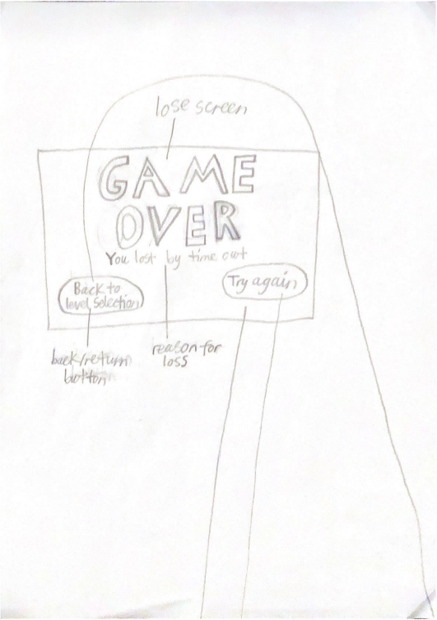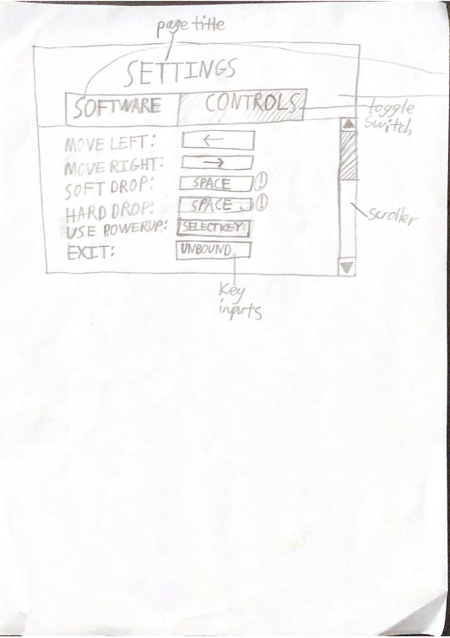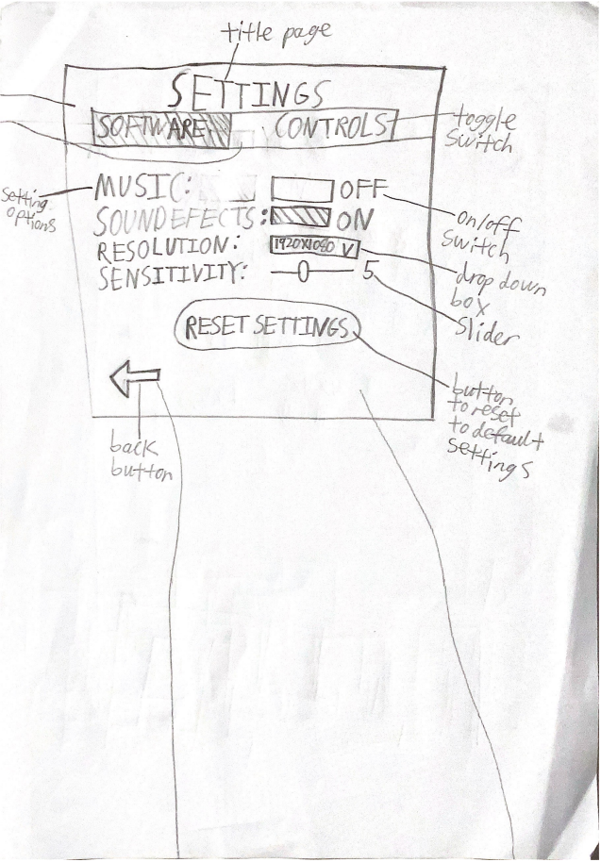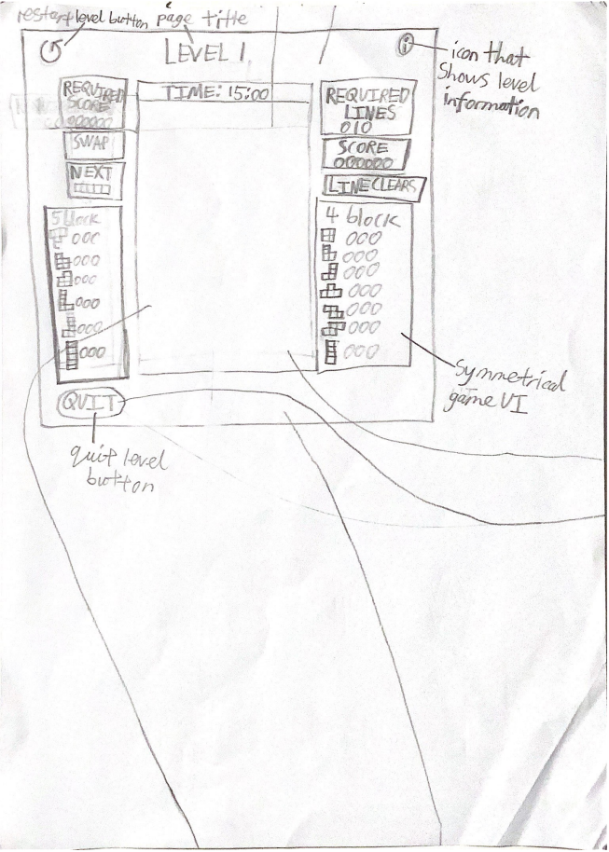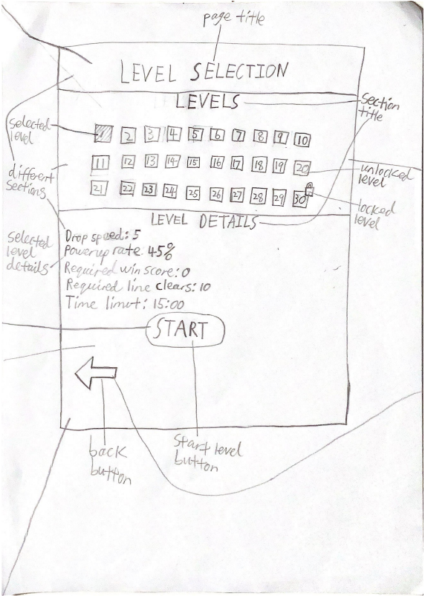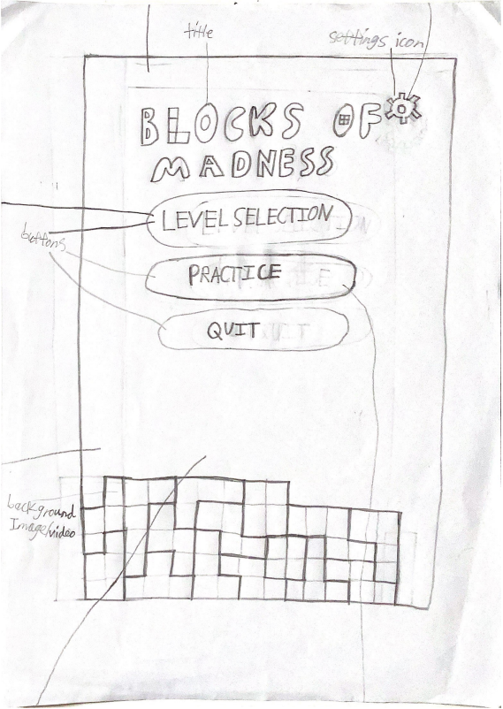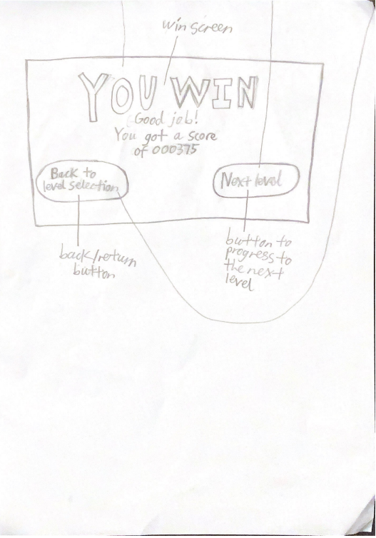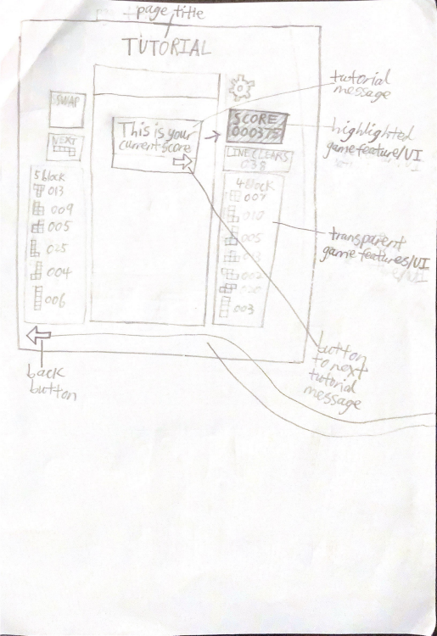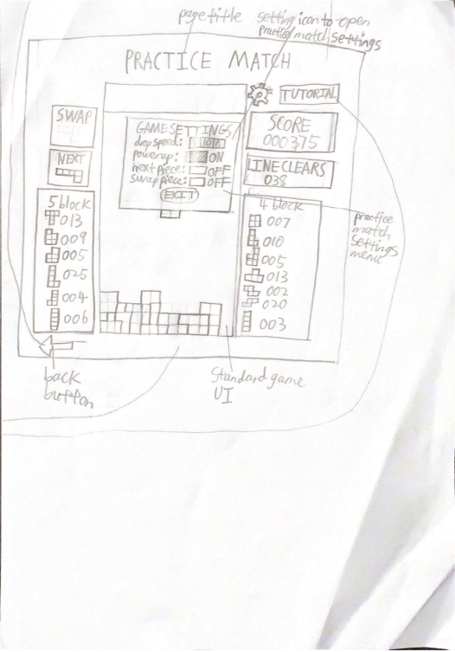

Adobe XD prototype

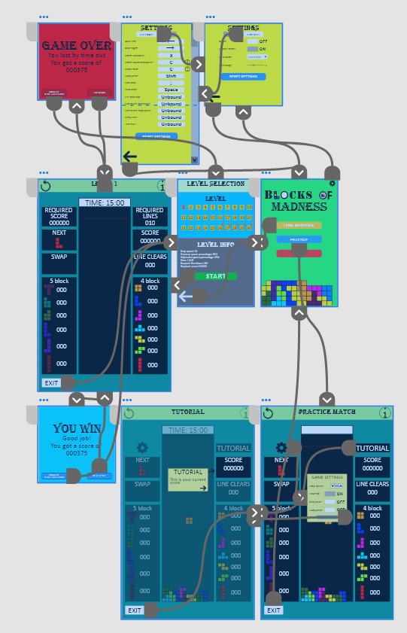

Lose screen

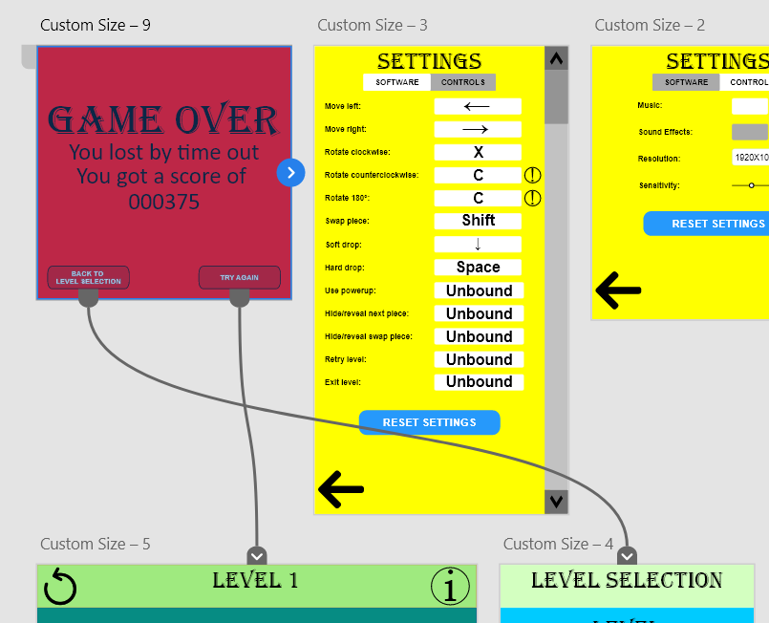

Control Settings screen

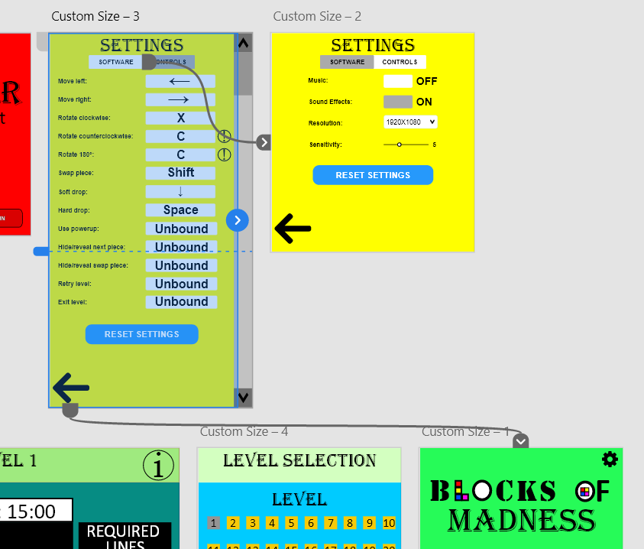

Software Settings screen

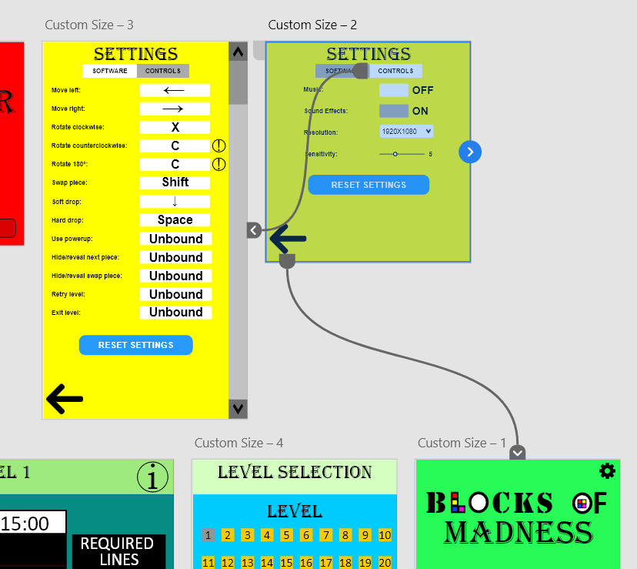

Game screen

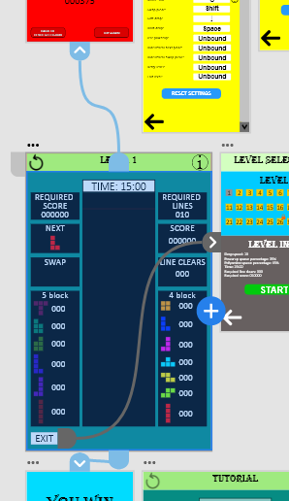

Level Selection screen

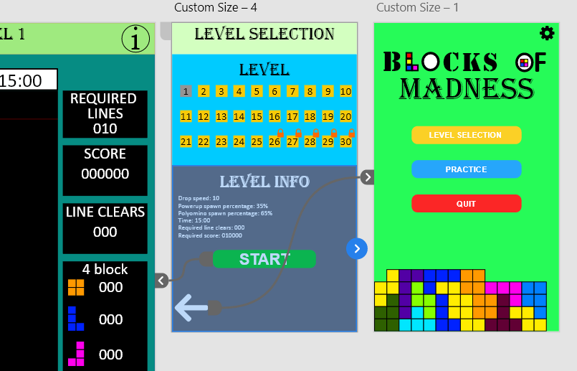

Home screen

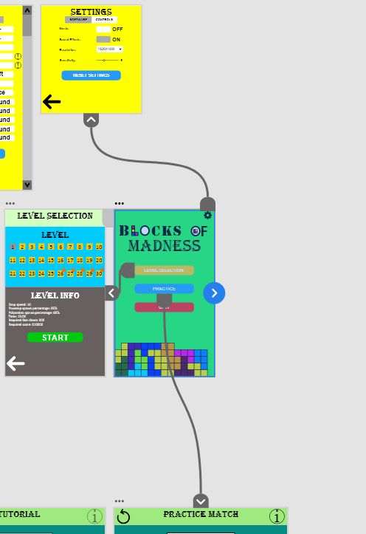

Win screen

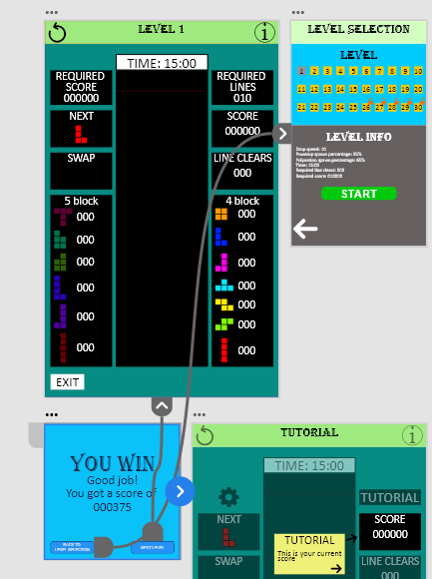

Tutorial screen

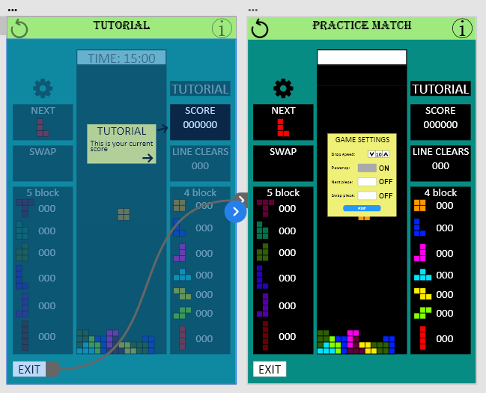

Practice screen

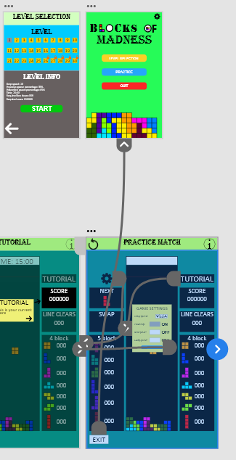

## Factors to be considered when selecting the programming language to be used

### Justify your choice of programming language for the project you have created. (1 page max)

Programming logic

The two types of programming logic are event driven programming and sequential programming. Event driven or object-oriented programming languages are used to create a program where the user can control which functions occur in the software. Sequential programming languages are used to code programs that executes in a distinct, pre-determined order of processing where users must follow a certain route throughout the software. The game that is being developed contains objects that can be controlled by the users and users can also control which pages they navigate to so the final software should be developed by an event driven or object-oriented programming language.

Features of the final solution

Each solution that needs to be developed will usually require different features only certain languages can create. My program will be designed to be a game so programming languages that can make games should be used rather than programming languages that use other types of programs like financial software or webpages.

Hardware and software specifications

Programming languages are usually designed for specific operating systems but the final software should be as accessible as possible so the chosen programming language should support as much operating systems as possible. When considering the hardware and software specifications of each programming languages, usually the compatibility of the operating systems and the drivers of the hardware devices need to be considered.

Graphical User Interface

The final GUI of the software should use design features that is widely used in other popular software so the users can be familiar with the functionality of the system. By implementing common design features the users have used before, developers can allow the users to easily learn how to use the final software.

Experience of the developers

When programming a software using a specific programming language, developers can implement the software project more quickly and accurately if they have used the programming language before. This is because the developers will already know how to use the programming language to create a software as well as be aware of the common errors that can occur. This means when selecting a programming language, the languages the developers have used before should be preferred over the other languages.

Selection

The chosen programming language has been decided to be Python because it is an object-oriented programming language, can create the software’s different features, can implement common design features from other software, can support most recent hardware and software devices, and the developers have used the programming language before.

## Factors to be considered when selecting the technology to be used

### Specify the performance requirements of the project. (1 page max)

Device performance

When considering the technology that will be used to operate the software, the performance of the devices needs to be ensured to be sufficient. This means each hardware component of the computer system always needs to be operating smoothly and never malfunction when the software is executed. The main hardware components that affects the software’s performance are the CPU, the RAM, the HDD, the sound and video cards, and external hardware devices.

CPU

The central processing unit is the computer’s main processing device that will process the user’s inputted data into information for the software to understand and process the software’s input data into information that can be outputted to the user. A requirement of the final software is to update the display of the software within 0.1 seconds which is similar to the input delay of other computer games. The developed game will be similar to Tetris Ultimate which requires a minimum CPU of the Intel Core 2 Duo E7300 or the AMD Athlon II X2 240. If the CPU is below the requirements, then the processing will slow down and the software’s performance will decrease.

RAM

Random-access memory is the computer’s short term memory where the temporary data that is used by the CPU to perform processes is stored. As the users use the software, temporary files will need to be created so the CPU can understand what needs to be changed when the software’s screen is updated. If a computer runs out of RAM, then the computer will start to slow down which means it will take longer to process actions. Similar to the minimum requirements for Tetris Ultimate, the minimum RAM requirements for a computer to run the software is 2GB.

HDD

The hard disk drive is the data storage device that stores permanent data within the computer system. This means the files that are required for the software to function is stored in the HDD and if there is no capacity left in the HDD, then computer operations like the software will start to slow down and there is an increased risk to crashing and file corruption. This means to have a good performance, the HDD should have enough space for the software to run. The minimum requirement is 0.6 GB like the minimum requirement for Tetris Ultimate.

Sound and video cards

Sound cards will allow the pc to be able to render audio and video cards will allow the pc to create a graphical display. Without sound or video cards, then there will be no audio or video displayed which means the users can’t use the software properly. Similar to Tetris Ultimate, the minimum requirements for sound card is DirectX compatible sound card with latest drivers and the NVIDIA GeForce GTS 450 or AMD Radeon HD 5670 for video cards.

External hardware devices

The users have to communicate with the software using input devices like mouses and keyboards and output devices like monitors and headphones. If these devices aren’t compatible with the software, then many errors will occur which means the performance will decrease. This means users should ensure the external hardware devices they use are compatible with the computer system.

### Benchmark one routine in your project and explain and apply the results (2 pages max)

Benchmarking a product is the process of measuring and comparing the performance of a software system or component against a predefined set of standards of benchmarks. By benchmarking a software, developers can find the areas in the software that needs to be improved, find ways to optimise the software, and ensure the final software meets or exceeds the industry standards. One requirement of the software is to respond to the user’s input within 0.1 seconds. The main function or routine that uses the most processing and responds to the user’s input is the soft drop function which is immediately performed after the down keyboard key is pressed or held. This function was able to be benchmarked by collecting the time during the beginning of the software and at the end of the processing, the difference between the old time and new time is printed so the time taken to process this function or respond to the user’s input will be displayed.

|  |  |  |  |
| --- | --- | --- | --- |
| Test | Software result (s) | Expected result (s) | Meets standard requirements |
| 1 | 0.004992485046386719 | 0.1 | Yes |
| 2 | 0.0065860748291015625 | 0.1 | Yes |
| 3 | 0.007003307342529297 | 0.1 | Yes |
| 4 | 0.010084390640258789 | 0.1 | Yes |
| 5 | 0.004998207092285156 | 0.1 | Yes |
| 6 | 0.00592803955078125 | 0.1 | Yes |
| 7 | 0.00916910171508789 | 0.1 | Yes |
| 8 | 0.0064983367919921875 | 0.1 | Yes |
| 9 | 0.0049953460693359375 | 0.1 | Yes |
| 10 | 0.0050144195556640625 | 0.1 | yes |
| 11 | 0.006043672561645508 | 0.1 | Yes |
| 12 | 0.007000446319580078 | 0.1 | Yes |
| 13 | 0.006008148193359375 | 0.1 | Yes |
| 14 | 0.006002902984619141 | 0.1 | Yes |
| 15 | 0.013076066970825195 | 0.1 | Yes |
| 16 | 0.010988235473632812 | 0.1 | Yes |
| 17 | 0.0049991607666015625 | 0.1 | Yes |
| 18 | 0.009810924530029297 | 0.1 | Yes |
| 19 | 0.004998922348022461 | 0.1 | Yes |
| 20 | 0.00498199462890625 | 0.1 | Yes |
| 21 | 0.0059909820556640625 | 0.1 | Yes |
| 22 | 0.006001472473144531 | 0.1 | Yes |

From these results, all the tests are shown to meet and exceed the standard requirements. This means the soft drop routine doesn’t need to be modified since it fits the standard requirements already.

# Stage 3: Implementation of Software Solutions

## Implementation of the design using an appropriate language

### Implement your Class structure in your chosen IDE with corresponding methods and data structures implemented from your algorithms and solution design.

Used library routines/modules

* tkinter module
* Image, ImageTk module from PIL
* random module
* time module
* threading module
* pygame module
* default python functions

Official website for python 3.11.3 documentation - <https://docs.python.org/3/>

### Continually update your data dictionary to match implementation

|  |  |  |  |  |  |
| --- | --- | --- | --- | --- | --- |
| **variables** | **Data type/structures** | **Format** | **Size** | **Description** | **Example** |
| rotationPosition | 4-dimensional array | [[[[‘X’, ‘X’], [‘X’, ‘X’], [‘X’, ‘X’], [‘X’, ‘X’]], [[‘X’, ‘X’], [‘X’, ‘X’], [‘X’, ‘X’], [‘X’, ‘X’]], [[‘X’, ‘X’], [‘X’, ‘X’], [‘X’, ‘X’], [‘X’, ‘X’]], [[‘X’, ‘X’], [‘X’, ‘X’], [‘X’, ‘X’], [‘X’, ‘X’]]] | 1000 | The 4-dimensional array includes the individual block positions of each piece rotation position of each type of piece | rotationPosition = [[[[3,7], [3,8], [3,9], [4,7]], [[2,8], [3,8], [4,8], [4,9]], [[2,9], [3,7], [3,8], [3,9]], [[2,7], [2,8], [3,8], [4,8]]], [[[3,7], [3,8], [3,9], [4,9]], [[2,8], [2,9], [3,8], [4,8]], [[2,7], [3,7], [3,8], [3,9]], [[2,8], [3,8], [4,7], [4,8]]], [[[3,7], [3,8], [3,9], [4,8]], [[2,8], [3,8], [3,9], [4,8]], [[2,8], [3,7], [3,8], [3,9]], [[2,8], [3,7], [3,8], [4,8]]], [[[3,7], [3,8], [4,8], [4,9]], [[2,9], [3,8], [3,9], [4,8]]], [[[3,8], [3,9], [4,7], [4,8]], 2,7], [3,7], [3,8], [4,8]]]] |
| blockColour | List | ‘X’,’X’,’X’ | 1000 | Contains the colours or images that need to be displayed on each block | blockColour=["#FF9900", "#0022FF", "#FF00EC", "#00E6FF", "#FFEC00"] |
| drop | float | XX.XX | 5 | drop is the speed the pieces will drop or fall at | drop=0.05 |
| pieceType | Integer | XX | 2 | A random number between 0 and 99 inclusive that will determine what type of piece is spawned | pieceType = 58 |
| Beat level | Boolean | X | 5 | States whether the level has been beaten by the player | beatLevel=True |
| Error message | string | XXXXX | 200 | States the error that has occurred in the system | Error message= ”Error 502 code has occurred because the servers is under maintenance” |

## Techniques in developing well written code

### During development adhere to good programming practice:

Follow standard naming conventions

Throughout the software, the developers used many variables. This means that the developers must use good variable names so they can quickly understand what each variable does and ensure future maintaining variables can understand what the function of each variable is. The variable names that were used in the software followed the camelCase structure where the first word was all in lowercase while the next few words had the first letter in capital case. This allowed the variable names to be readable and the variable names should be relevant to their functions so the developers should be able to understand what the variable does.

Internal documentation

Throughout the implementation of the software, the developers should write comments to describe how each group of code works. This should be done so they will always remember how each group of code works if they forget after focusing on other parts of the software’s code. Additionally, internal documentation can also help other programmers such as other developers that also worked on coding the software and future maintaining developers understand how the code of the software works.

Version control/Backup

Throughout the whole implementation process, the developers frequently created backups and version control files. By naming these files to be categorised by numbers like V1.0.1, the developers can understand what feature is being developer in each group of version control files. In this software project, V0 represents all the feature that focuses on making the game function properly while V1 focuses on making sure the software’s GUI functions work. The second group of numbers focuses on getting a specific function to work. For example, V0.5 focuses on making sure the user can move the piece left or right while V1.4 focuses on making sure all the different screens combined together work functionally. The last group of numbers are files that are saved frequently to make sure progress isn’t lost in case the developers modify the code to be worse than before. For example, V0.6.1 only drops the piece every second when the right shift key is pressed while V0.6.2 makes the piece automatically drop every second.

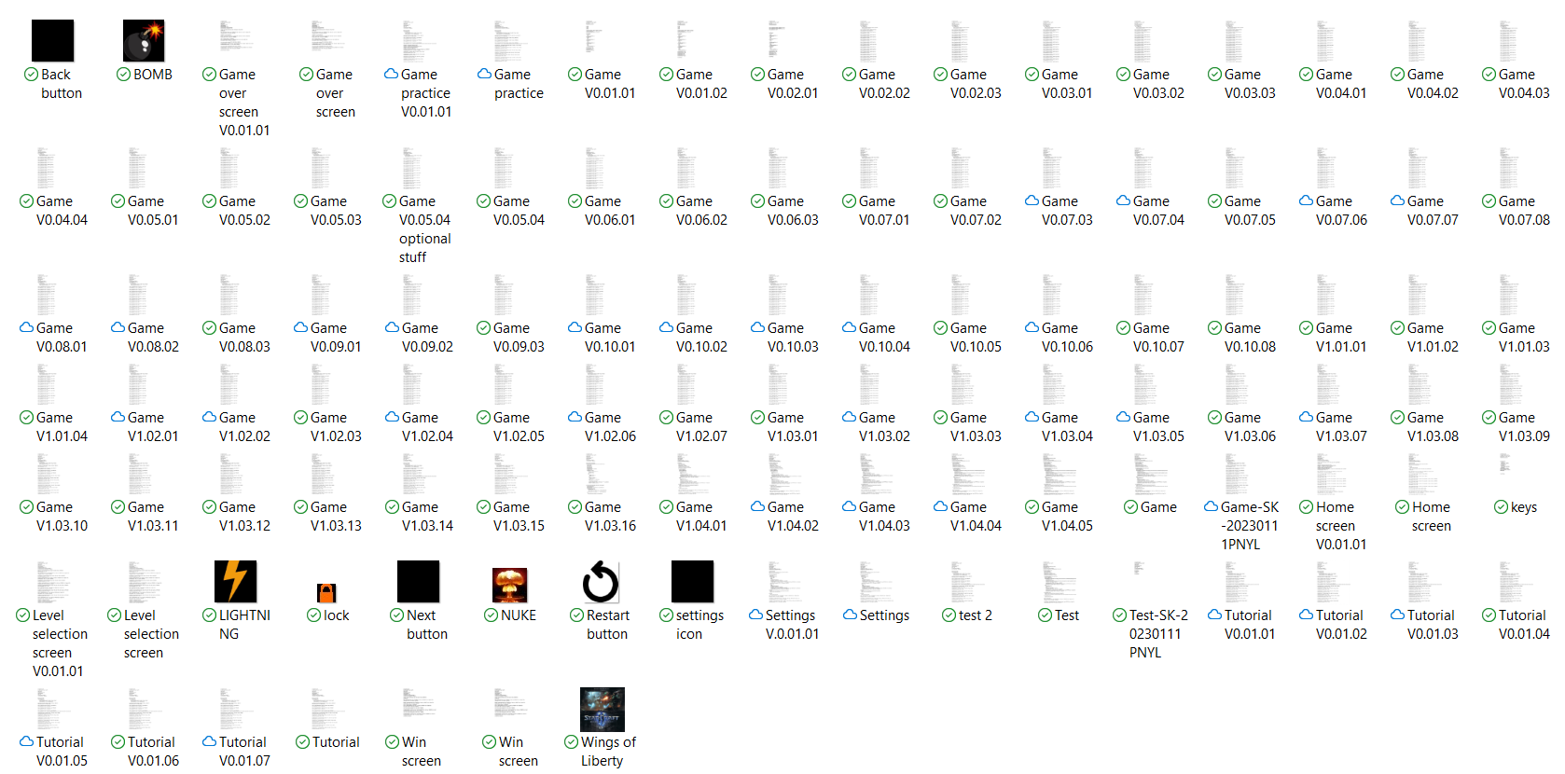

### Explain how you have coded to increase maintainability of your code. (1 page with examples)

Good variable names

Throughout the implementation of the software, the developers created meaningful variable names for all of the variables that are used throughout the system. This should increase the maintainability of the code since future developers should have an easier time understanding what the purpose of each variable is. For example, in the code the variable ‘testYpiece’ is used so the new situation with the new ‘Ypiece’ value can be tested to see if it works or not but if an useless name is used, then other developers could have a harder time understanding what the variable does. In the final software solution, at least 50 variables are used so if useless variable names are used for each variable, then developers who don’t know how the code works could have a hard time tracking the areas a specific variable is used. However, if the variable names relate to their functions, the other developers can use that to remember where each variable should be used. For example, in the software, anything variable that has the word score in the name like ‘scoreNumbers’ is most likely going to appear in the score sections like the ‘lineClearScore’ function that calculates score when a line clear is performed or the ‘displayScore’ function that displays the score or the ‘scoreNumbers’ variable.

Internal documentation

When creating the code, comments or internal documentation is written so the developers will know what each section of code does when they try to understand or modify how the code works. The comments should be placed within each function and at the beginning of a section of a group of functions so the developers reading the code knows what the following section of code is about. For example, the ‘start/end game functions’ comment signifies the functions in the next section helps the game start or end. The comments that are in a function should describe what the whole function is about or describe what a specific action of a function does. For example, the ‘start’ function is described as initiate a countdown when the game begins and the comment talking about ‘endGame1’ and ‘endGame2’ discuss how closing and opening the game will affect these variables to make sure an unexpected result doesn’t happen or fix a specific bug in the software.

Use of functions

By using functions to group specific features of the software, the developers can make the code more readable. This means that when future developers try to read the code, they should have an easier time since the code won’t be clumped together and the helpful function names can help them find what specific feature of the game they are looking for. For example, the ‘startLevel’ function and the ‘End’ function are placed next to each other and by making them into separate functions, the other developers can easily read and understand what each group of code does. The useful function names also helps the developers understand the End function occurs when the game ends and the ‘startLevel’ function happens when the level starts.

### Document five errors that you corrected during development (3 pages max)

Logic error 1

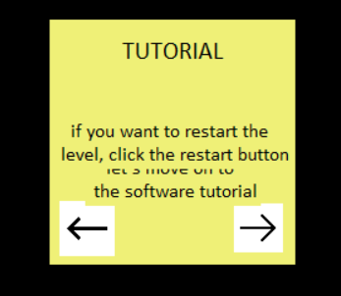

This error is a logic error that occurs in the tutorial screen near the end of the game tutorial part of the tutorial. This occurs because instead of deleting the usual two objects of the tutorial’s text and title, there is a third text that needs to be deleted and trying to delete the third text caused some issues that resulted in this logic error. Since the developers didn’t change much since the last time the version control file was created, the developers knew the area the issue must occur since the developers only changed the code around a specific area. After reading through the code in the area again, the developers found that the reason this logic error occurred was because the text label variable wasn’t recorded as a global variable so the software can’t find the referenced variable when it is asked to delete the text. After making sure the label variable was global, the text was deleted when a new part of the tutorial shows up which means the logic error was fixed.

logic error 2



The second logic error occurs when the user moves the piece at the same time as the piece drops down. When this happens, the system tries to perform two functions at once where two sets of new pieces are added to the active piece list in mixed order and since each function deletes the items in the list until the list is empty, this could result in a hanging piece if two functions occur at the same time. At first, the developers tried to fix this by adding a black square where the piece was previously since it only appears where the piece has travelled but the developers found that it took too much processing. After looking at the code that affected this error, the developers was able to fix this issue by making the functions repeat deleting the items in the list by the number value stored in ‘pieceBlocks’ which is the number of blocks the piece has instead of deleting until the list is empty. This new method of processing does everything it did before the same except it also accounts for this specific scenario and it fixes the logic error.

runtime error 1

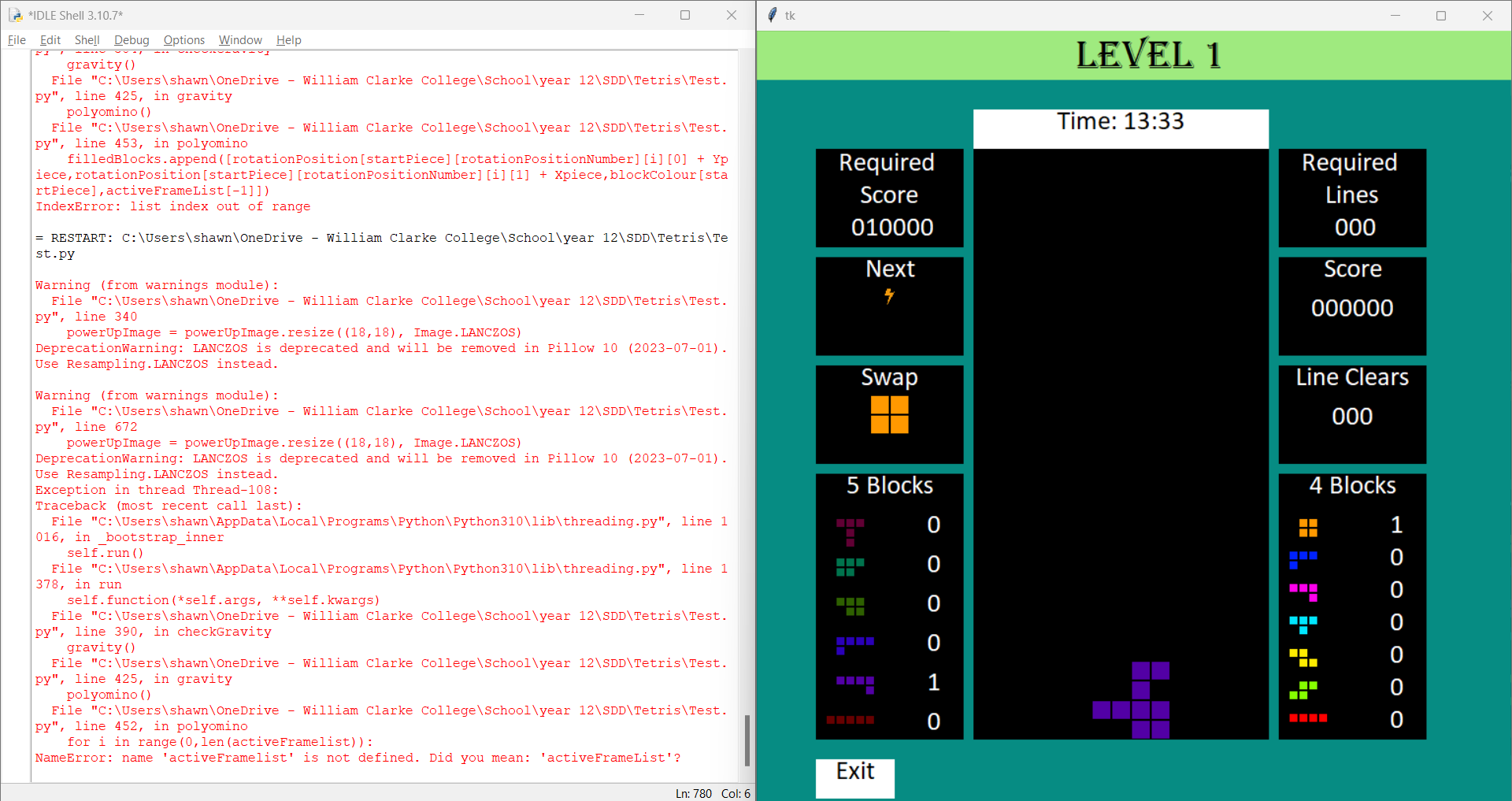

Similar to the last type of error, this error occurs when two functions try to modify the different pieces lists at the same time. The software tries to append an item in the ‘activeFrameList’ list to other piece lists every time a block of the active piece is removed when it is being turned into a stable piece. If two functions are running at once, then there is a chance there will be no items in the ‘activeFrameList’ list when the piece is being transferred so the system doesn’t know what to append which leads to the game halting or crashing. To fix this issue, the developers made sure the actions in each functions are only repeated by the number value that is stored in the ‘pieceBlocks’ variable and the developers also added additional requirements such as making sure the length of the ‘activeFrameList’ list is never less than the number value in the ‘pieceBlocks’ variable when the switching from active piece to stable piece function is executed. The additional requirements for executing the loop should ensure the ‘activeFrameList’ list will never be empty when the software is trying to append or remove an item in the list.

runtime error 2

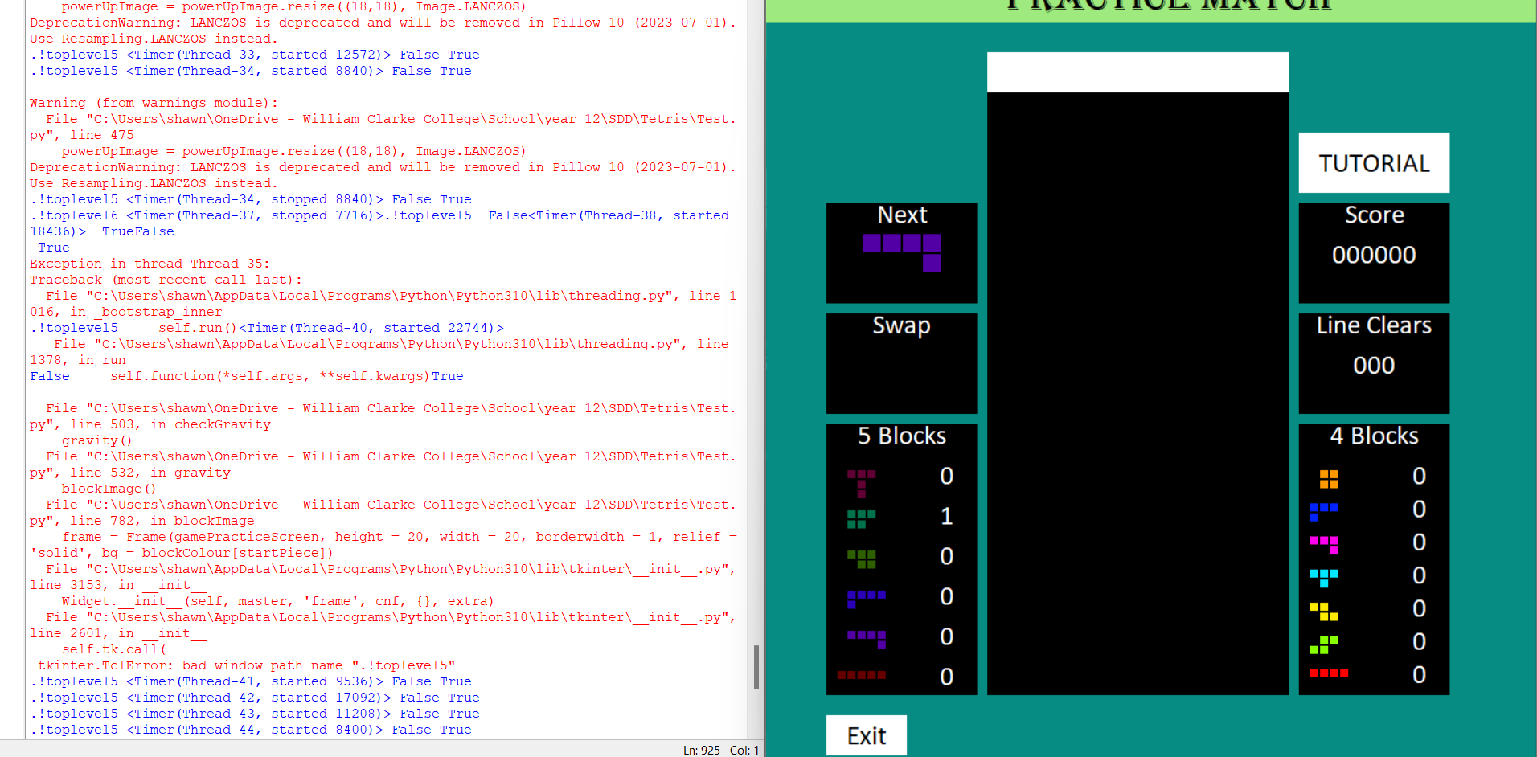

The second runtime error occurs because of issues that have occurred when the screens or separately created modules have been combined together. This specific error occurs when the software is processing something in the game screen and the game is exited through the exit button in the game screen. This occurs since the software is trying to modify the lists of the current game screen function but since the game is exited through the exit button, the game screen is deleted so the software can’t continue to modify the lists since it can’t reference the lists from a deleted screen. Even if the screen is deleted, the actions in the screens are never halted so the gravity threading timer will always be running which means the game will be running in the background. This means if the user tries to open another game screen, the game will break since it is running two games at the same time and the second screen will usually encounter an error that halts the game completely or runs the game in the background without any graphical display of the updated piece grid positions. To fix this issue, the developers had to add some additional functions that ran when the exit button was halted like adding a function that stopped the timers or after functions that ran during the game. The developers also made the game end when the exit button is pressed so the software won’t continue to run the game when the game screen is destroyed. After this issue has been fixed, the developers realised there was another situation where the same error occurred. If the game is updating the image of the pieces in the grid as the game is exited and the game screen is immediately opened before the threading timer from the previous game screen has been executed. This causes the software or game to crash since the ‘gameover’ variable is set to true instead of false and the threading timer from the previous game screen now runs the game in the background instead of halting it which causes the software to break. When reading through the code, the developers realised they couldn’t use the usual active or non-active method to fix the bug. In this method, the developers would usually use a variable to display if a function is being executed or not and this can be used to determine if other functions are ran or not. This can’t be used in this situation since the developers are trying to get the old function to not run at the same time as the new function but both functions use the same code so both functions would run either way. This means that the developers have to use a two variable system. In this system, the software uses two variables called ‘endGame1’ and ‘endGame2’ where if the game isn’t running, then the two variables don’t equal to each other and when the game runs after the game countdown is finished, the two variables are set to equal each other. These variables are also used in the drop piece function where it compares if the two variables are equal to each other to see if the game is active or not. This means the threading drop timer from the previous game should always halt since there will always be enough time for the threading timer to run when the two variables are not equal to each other which means the previous game will never run in the background.

Syntax error

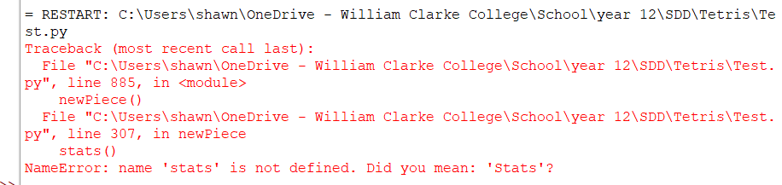

The IDE automatically tells the developers what syntax or grammatical error they have created, where the error is located, and it also recommends them some ways they can fix the error. In this example, the function ‘stats’ is misspelt and as a result, the IDE tells the developers where the word is misspelt and gives them some recommendations on how to fix the issue.

### Explain three methods you used to detect and correct errors you encountered (1 page max)

Flag

Flags are used to indicate if a certain condition has been met. This type of error detection is usually used if the developers wants to check if their code works or not. If a function is supposed to activate another function, a flag that displays or prints a statement can be placed in the activated function and when the developer tests the function, they can tell if the function is correctly executing the second function or not. Usually if the statement is printed when the initial function is tested, then it means that the function is executing the second function correctly. This testing method was used to help detect where the logic and runtime errors in the software originated from because by placing a lot of flags around the code, the developers could tell which code were executing correctly and which code weren’t. By detecting which parts of the code are functional, the developers can try to fix and make the functions fully functional.

Debugging output statements

Similar to flags, debugging output statements are used to display or print the values of the variables. This type of error detection method can be used to track the values of the variables as the software is executed and during the testing of the software, the developers can determine if the printed variable values are meant to be correct or not. If they found the variables stopped being correct after a certain point, they can narrow down the area the error has occurred from anywhere within a function to anywhere between two small sections of code. Since many debugging output statements can be used at the same time, usually the printed statements will describe what part of the code the statement is printed from. In the software, usually random, unique words like ‘yes’ and ‘no’ are used in different debugging output statements to allow the developers to easily identify where the statements are located in the code but full sentences aren’t written to save time.

Driver

Unlike flags and debugging output statements, drivers are subroutines or functions that are created to test the operation of other functions. Usually drivers test the value of a selected variable so the developers can check if the value is similar to the value it is expected to be at. In addition to checking variables, the drivers can also call a specific function to be tested. In the finished software, the developers created a driver function called ‘Shift1’ that executed when the right shift key was pressed. Throughout the implementation of the software, the driver function was used to print the values of multiple important variables such as the full list of the ‘activeFrameList’ and also test the functions of the powerup by making the game system always spawn powerups after the right shift key has been pressed. By using this driver function, the developers can find if the specific tested variables or functions produce an unexpected result and if they do display an unexpected result, the developers can search for everything that is related to the tested variables and functions so they can try to fix the error.

### Explain two software debugging tools you used in your IDE and provide screenshots of them in action. (1 page max)

syntax error detection

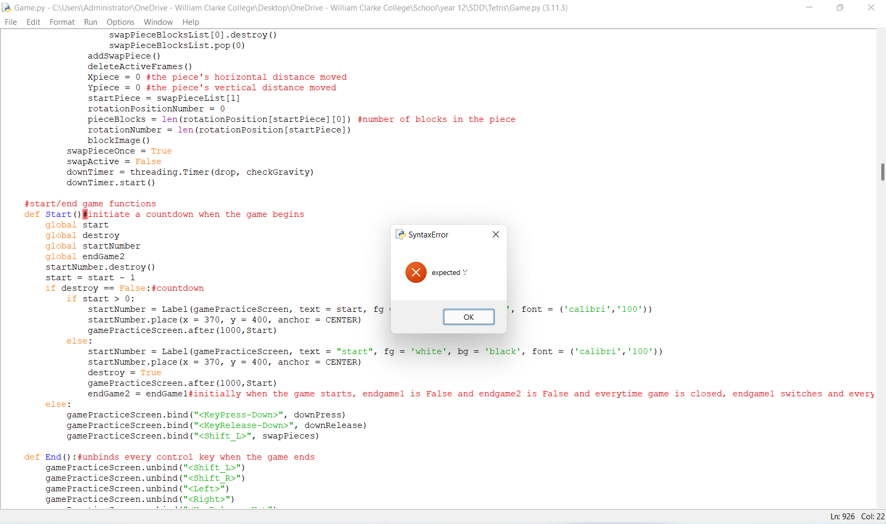

The first software debugging tool that is embedded into the python IDLE IDE is the syntax error detection. In this automated system, the IDE checks through the whole code to check if there is any syntax or grammatical error like the one that is shown in the screenshot. In the image, the developer forgot to add a colon at the end of the function name. As a result, the IDE doesn’t see the group of code as a function since it doesn’t know what the defining function line means but it can recognise the line is similar to a line that would be defining a function since it has the same structure of having the ‘def’ word at the beginning and the function name at the end. This means the IDE can suggest to the developer what needs to be added to the line to make it define a function and fix the syntax error.

runtime error detection



The second software debugging tool is embedded into the python IDLE IDE terminal where if an error is detected during the execution of the program, the terminal prints where the processing was at when the error occurred. It also prints which functions have been executed before the error and it also points out which part of the line the error occurs in. This gives the developers an easy time in finding where the runtime errors are located.

## Documentation of a software solution

### Create appropriate user documentation

* User Manual (separate document)
* Installation guide (submitted separately – indicate where it can be found.)
* Online Help (in project – describe what is available)

## Hardware environment to enable implementation of the software solution

### Explain Hardware requirements to run your software solution including minimum requirements, any additional hardware or peripherals required / desirable, and any appropriate device drivers. Describe any differences in these to the original design specifications. (2 pages max)

Minimum Hardware Configuration

The software has only been tested on one computer so the minimum hardware requirements can’t be determined yet. However, since the software ran with perfect performance on the computer, this means the hardware and software statistics of the tested computer can be used as the minimum hardware and software requirements for the final software.

The minimum hardware requirements are having a processor of an Intel® Core™ i5-6300U CPU @ 2.40GHz 2.50 GHz, 8.00 GB of installed RAM with at least 7.88 GB of ram available, a 64-bit Windows 11 Pro operating system and a x64-based processor, 238 GB HDD size storage, sound card models of Intel® Display Audio from Intel® Corporation and Realtek High Definition Audio V6.0.9239.1 from Realtek Semiconductor Corp., and video card models of Intel® HD Graphics 520 from Intel Corporation.

When the new hardware requirements are compared to the old requirements, the both processors have the same amount of cores, the new processor has a processor frequency speed of 2.40 GHz while the old processor has a processor frequency speed of 2.66 GHz, the new processor has a bus speed of 4000 MHz while the old processor has a bus speed of 1066 MHz, the new minimum RAM is 8 GB while the old minimum RAM is 2 GB, the new operating system has to be a 64-bit Windows 11 Pro while ethe old operating system is a Windows 7 SP1, Windows 8/8.1, and the 32-bit and 64-bit versions of Windows 10, the HDD has a 238 GB size storage while the old HDD only needs 0.6 GB, the new sound card is the Intel® Display Audio and the Realtek High Definition Audio with the latest drivers while the old sound card can be any DirectX compatible sound card with the latest drivers, and the new video card uses the Intel® HD Graphics 520 while the old video card uses the NVIDIA GeForce GTS 450. This means the new minimum hardware specifications are higher than the old minimum hardware specifications.

Possible Additional Hardware

In addition to the minimum hardware requirements for the user’s computer, functional mouse and keyboards are also needed to use the software. This is because in the software, the user have to press certain keys and mouse presses. If the user has a mouse that can move the cursor around and left click and has a keyboard that can use the arrow keys and the shift keys, then they should be able to use the software. Other additional hardware can also be used to help the user’s computer reach the minimum hardware requirements if they haven’t been reached yet. Examples include RAM modules that can increase the RAM in the user’s computer if possible and external hard drives like USB that can increase the user’s computer’s storage space.

Appropriate Drivers or Extensions

Drivers are needed in hardware device to ensure the devices can communicate correctly with the operating system. These drivers should also be the latest versions so the hardware devices can function without errors. In the setup that is required to use this software, drivers are used in each hardware device but the drivers that need to be updated to the latest released version are the sound cards, video cards, mouses, and keyboards.

## System Documentation

### Refine your IPO (at least 3 levels), DFD, Structure Chart, Context Diagram and System flowchart for your software solution.

IPO

|  |  |  |
| --- | --- | --- |
| Input | Process | Output |
| Up key status  Rotation position of current piece  Number of unique current rotation positions  Number of blocks the current piece has  X and Y coordinates of the blocks of the current piece  The amount of blocks that are stable  X and Y coordinates of the stable blocks  The amount of items in the activeFrameList | 1. Check up key status 2. if up key status is pressed and released  * Set pieceInGrid to true * Get the next rotation position number  1. if the X and Y coordinates of the blocks of the piece’s next rotation position, set pieceInGrid to False 2. if the X and Y coordinates of the blocks of the piece’s next rotation position is equal to a stable block’s X and Y coordinates, set pieceInGrid to False 3. If pieceInGrid is equal to true and amount of items in the activeFrameList is equal to the number of blocks the current piece has  * Set rotationActive to true * Set the piece’s current rotation position to the next rotation position * Delete current piece blocks from activeFrameList * Add new piece blocks to activeFrameList * Update the grid image | Updated piece rotation position  Updated activeFrameList  Updated grid image |
| Down key status  checkGravityActive  Level drop speed  Level check drop speed  Gravity timer | 1. Check down key status 2. If down key is pressed and checkGravityActive is false  * Set gravity to 0.05 seconds * Set check gravity speed to 0.04 seconds * Stop gravity timer * Set checkGravityActive to true * gravity()  1. If down key is not pressed  * Set gravity to level drop speed seconds * Set check gravity speed to level check drop speed seconds * Stop gravity timer * Set checkGravityActive to true * gravity() | New gravity value  New check gravity speed value  Updated checkGravityActive |
| Gravity timer  stableFrameList  filledBlocks  startPiece  randomly generated type of piece  newPieceList  4D piece dictionary  swapPieceOnce | 1. Stop gravity timer 2. Clear the stableFrameList 3. Update the grid image 4. Append each item in filledBlocks to stableFrameList and update the grid image 5. Set Xpiece and Ypiece to 0 6. randomPiece() 7. Add startPiece to newPieceList as the last item 8. delete the first item in newPieceList and shift each item forward by one 9. Set rotationPositionNumber to 0 10. Define pieceBlocks and rotationNumber 11. Spawn the piece and update the grid image 12. Update the piece stats 13. Get next piece 14. Update next piece box 15. if swapPieceOnce is True  * Set swapPieceOnce to false  1. checkWinCondition() and checkLoseCondition() 2. start gravity timer | Updated stableFrameList  Updated Xpiece and Ypiece values  Updated newPieceList  Updated rotationPositionNumber  Updated pieceBlocks and rotationNumber  New piece in the grid  Updated piece stats box  Updated next piece box  Reset swap piece system  Check win condition  Check lose condition  Gravity function |

Context diagram

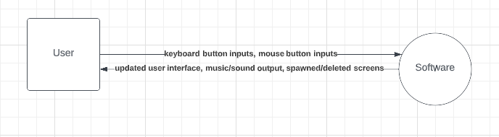

Data flow diagram

Check pdf

System flowchart

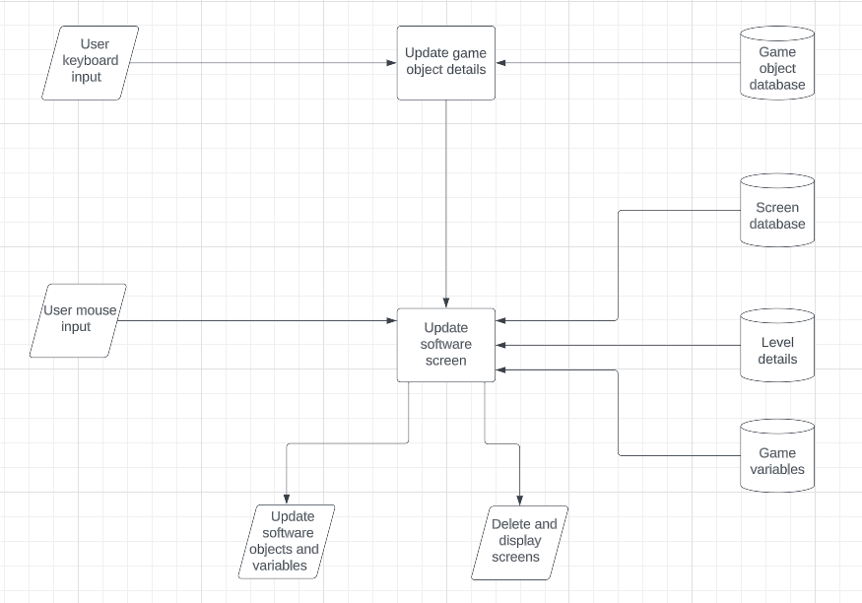

Structure chart

Play music soundtrack

Play music

Game system

Stop music soundtrack

Settings screen

Close home screen



Practice game

Music

Music

Settings screen

Practice game screen

Initial game variables

Level selection screen

Game level variables

Level selection screen

Quit

Disable all buttons in the home screen

Disable home buttons

Enable all buttons in the home screen

Settings screen



Close settings screen

Play music

Stop music

Music

Stop music soundtrack

Music

Music

Music

Play music soundtrack

Play/Stop music soundtrack

Switch music

Music

Music

Enable all buttons in the home screen

Enable home buttons

Exit settings



Close level selection screen

Game screen

Disable all buttons in the home screen

Start level

Exit level selection screen

Disable all buttons in the home screen

Disable level selection buttons

Updated level variables

Level 5

Updated level variables

Level 4

Updated level variables

Level 3

Updated level variables

Level 2

Updated level variables

Level 1

Enable all buttons in the home screen

Enable home buttons

Enable all buttons in the home screen

Level selection screen



Polyomino

Powerups

Powerups

checkWinCondition

Polyomino

newPiece

Gravity

Powerups

newPiece

Gravity

Polyomino

checkLineClears

Close level selection screen

Exit level selection screen

Enable all buttons in the home screen

Enable home buttons

Enable all buttons in the home screen

checkLoseCondition

Controls

Score

Start level



Back

Forward

Close level selection screen

Exit level selection screen

Enable all buttons in the home screen

Enable home buttons

Enable all buttons in the home screen

Tutorial

* Log Book – (ongoing, on Connect.)

# Stage 4: Testing and Evaluation of Software Solutions

## Testing the software solution

### Evaluate the success of the completed software solution against the criteria (understanding of the problem and specifications) determined earlier in the documentation. (2 pages max)

Entertainment of the software

The entertainment of the software is subjective since everyone has different opinions so it is hard to measure. It might be possible to measure if a lot of people tested the software but there isn’t enough time to publish the software and send a survey to collect results from the users who have played and tested the software. In addition to this, how entertained the users are from using the software can vary depending on how long they have been playing the game.

Software’s improvement of skillsets

Similarly, the software’s impact on the user’s skillsets is subjective since some users might improve while other users gain nothing. There might be a way to find the software’s impact on the user’s skillsets if the user’s skills are recorded before and after the users using the software. However, there isn’t enough time left to organise and record these results.

Functionality

The software is designed to feature functions that allows the user interface to be displayed smoothly at 30 frames per second, allows the game mechanics to run accurately with no errors, constantly updates the score system accurately, ensures the randomised piece generation system is fully functional, and makes sure the software is always responding to the user’s inputs within 0.1 seconds.

Game mechanics

When testing the software, it was found that all the game mechanics worked. These game features were moving the piece left and right, automatically dropping the piece at a certain speed, soft dropping the piece, using different powerup functions, rotating the piece, changing the piece from a controllable to an uncontrollable state, using a score and line clear system, and using a win and lose system. When this was tested on the Windows 11 pro computer, the game mechanics were tested in a wide range of scenarios and the game features worked in each scenario so the game mechanics should be always functional.

Piece randomised generation system

Similar to the game mechanics, the piece spawning system also worked in all of the scenarios. This meant that currently, there are no known issues with the pieces randomised generation system.

Response time

When benchmarking the response times, it was found the average response time for the software to respond to the user’s input or update the screen after a function was 0.003 seconds with the results varying from 0.001 to 0.01 seconds. This meant that the software can always respond within 0.1 seconds. However, this processing only occurs when the system is functioning normally but there is a bug where after using the software for a long period of time, the software starts to slow down. This causes the processing of the software to take longer which means there would be a long response time needed.

User interface

Similar to the response time, the user interface initially starts to have quick updated images of frames per second but it slows down the longer the software is used and the software eventually crashes. This means the game’s functionality requirements can only be compared to the software for a short amount of time. The frame rate is the amount of times the software can display a new image in a second and the processing speed of the software is around 0.003 seconds so theoretically, the max frames per second should be around 333 but the most used frames per second will be the user using the soft drop function which will drop the piece once every 0.05 seconds. This means that the average frames per second should only be around 20 which doesn’t meet the functionality requirements.

Conclusion

In conclusion, the aim of the software is very subjective so it is unknown if the software will meet its aim or not. However, the functionality requirements are designed to be objective. When comparing the results of the final software to the functionality requirements, it was found that all the processing and game mechanics of the software worked perfectly, but the software’s processing was a bit flawed. This could be due to the system randomly slowing down and eventually crashed as the user used the software or the software’s average frames per second not being set to be high enough. This means that overall, the software didn’t meet the set functionality requirements. This also means that it is unlikely that the software will meet its aim since the software isn’t functioning as the clients expected.

### Test the solution at all levels with original test data (Module, Program, System) and document results (2 pages max)

Module testing

Module testing is where the developers tests each module or subroutine separately. Throughout the majority of the implementation, the main game software was tested multiple times. This was done to ensure that the errors in the module code can be minimised. It would be hard to document the whole module since there are a lot of functions to test which would mean lots of test data that needs to be used due to the number of possible scenarios that could occur. For example, for the functions that related to the gravity mechanic, the developers had to test the piece dropping by itself with no keys being pressed, test pressing a movement key, which are moving the piece left or right or rotating the piece, as the piece dropped, test pressing a movement key when it isn’t dropping, test soft dropping when the piece isn’t dropping, test soft dropping when the piece is dropping, test swapping the piece through the left shift key, test swapping the piece just as the piece dropped, test holding any key except the down key, and test holding the down key. Throughout these tests, developers found and fixed multiple issues. Some examples of bugs include the piece being dropped twice multiple functions are executed at once which occurred when the developers tested soft dropping the piece as the piece dropped, the piece leaving a piece hanging in the air that can’t be removed by anything when the developers tested pressing the movement keys at the same time as the piece was dropped, and swapping the piece as the piece dropped caused the whole game to crash and stop running which was detected when the developers tested swapping the piece as it dropped.

Program testing

Program testing is where the developers tests all the modules combined together as a whole software. In the current software project, the developers combined the modules together at the end and performed program testing to make sure that the software doesn’t contain any errors. After combining the modules together to make the final software, the developers tested scenarios such as the linking of buttons from one screen to another, the deletion of one screen and the creation of another if a button is clicked, the creation of the win or lose screen if the user wins or loses in the game screen, the level selection screen saving its progress if the user quits and reopens the screen, making sure the variables from the level selection are correctly transferred to the game screen, and making sure the music can be started and stopped from different screens. Some of the errors that occurred during program testing was the system crashes if the game was exited and immediately reopened when the software was processing something in the game level, the level selection screen didn’t save its progress so if the user deleted the screen and reopened it, they would lose all of their previous progress, and initially, the exit button for the game and practice screens didn’t work.

System testing

System testing is where the developers test the software to make sure the hardware, software, data, personnel, and procedures of the software can work together to make an efficient and accurate software. This means to do system testing, the developers have to make sure the system works using a wide range of hardware to run the software. Some ways developers can test this is using different computer models or different computer operating systems, and using default and wired mouse and keyboards to test the software. When developers tested the Intel® Core™ i5-6300U CPU computer model with a wired mouse and keyboard, it displayed and processed everything perfectly including outputting the music, updating the game grid correctly, saving the progress on the level selection screen, and accurately using the game features. When the software was ran on the Intel® Core™ i7-10510U CPU with the default or in-built mouse and keyboard, everything worked as expected like the last model but the processing was noticeably worse than the last model. The developers noticed this through the slower response speed and the software’s lagging and eventual crash happening much sooner than the last model. When comparing when the game crashed, the last module would usually crash at around 45 minutes while this model would crash around 30 minutes. The last computer the developers tested was the macbook air 2019. This computer had a different operating system than the other two models. This is suspected to be cause of the different issues that were experienced by the last model but not encountered in the first two models. These errors are the home screen buttons have no colour and they are coloured white with an engraved pattern instead of having colour like red, green, and blue and no engraved pattern, the home screen settings gear icon isn’t transparent, the game processes the soft drop much faster than the other two models or an error in the code led to the game processing the actions really quickly and this error led to some pieces not being registered or transferred to stable blocks when they are meant to and instead they disappear, and when the user tops out by reaching the top with their pieces, the software crashes after a few seconds. From these results, the developers can observe that the software should work with different types of mouse and keyboards but the operating system the game can be ran on seems to be limited to Windows 11 since both of the first two models were Windows 11 while the last model was a MacBook.

### Explain the types of test data used on the software solution (1 page max)

Test data is the data that is used to test the software to make sure the system is working as intended. Since the software is a graphical game that focuses on moving the objects around, it is hard to individually change the different variables as test data. This is because the software expects the variables to be changed in an expected order and if they are suddenly changed at an unexpected place in the code, then the software could break since it wasn’t programmed to handle the new scenario. Instead, the developers have to try to input button presses to reach certain scenarios so certain scenarios can be met which means the developers can test if the software works in these scenarios or not. By testing a combination of key presses, the developers can reach certain exclusive scenarios that can only be reached through the specific key press combination. For example, if the left arrow key is pressed at the same time as the piece drops, then the piece will drop diagonally to the south west direction which can only be achieved by the specific combination of button presses.

### Demonstrate the actual vs expected test output of a given algorithm (1 page max)

Algorithm result



The expected result of the algorithm is it will drop with the gravity function whenever it is not touching the ground but if it is touching the ground, then everything in the vertical column is deleted and score is added through the lightning score formula function.

Software result

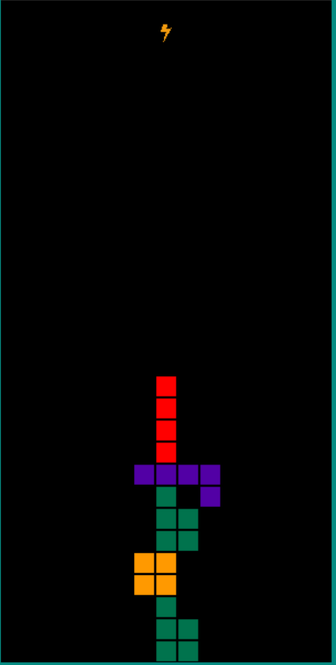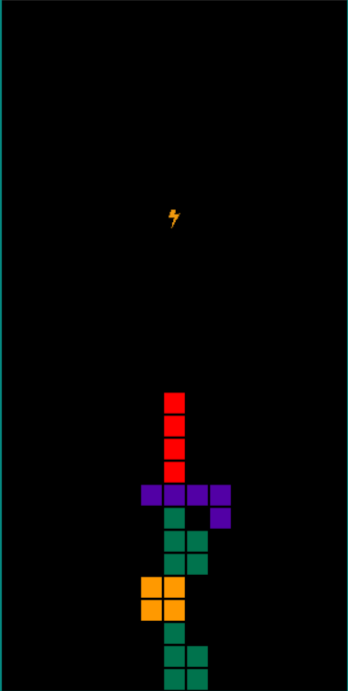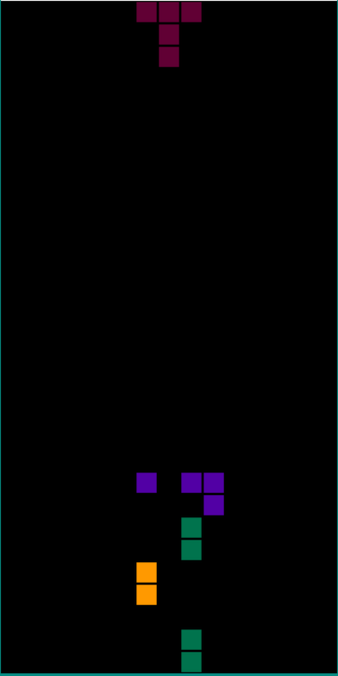

Similar to the algorithm’s expected result, the software result drops the powerup if possible until it is in contact with the ground or a piece and if that happens, every block in the vertical column is deleted.

## Post Implementation Review

### Document a discussion with the client including aims and what was achieved (max half page)

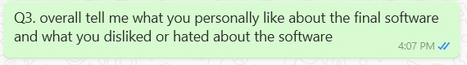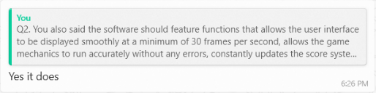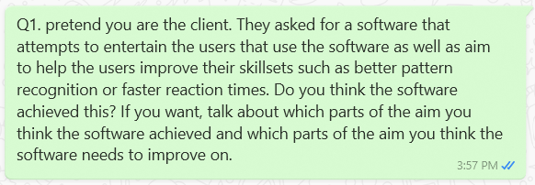

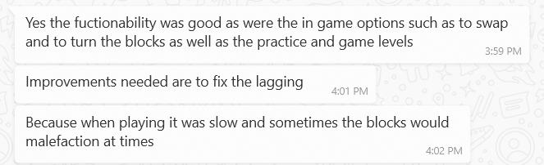



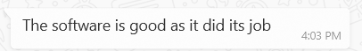

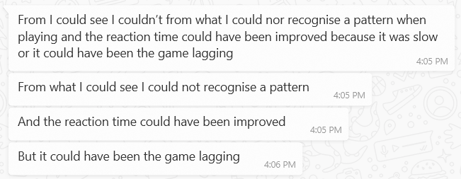

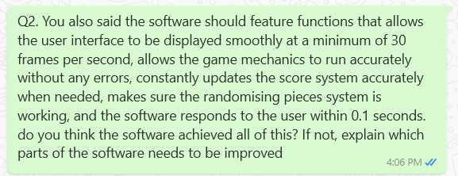

### Document client satisfaction / dissatisfaction with the result. (1 page max)

Client satisfaction

From the conversation, the client stated that he was happy with the final result of the software since he was entertained by the software and he thought users could improve their skillsets if they played the game. He also stated that he was satisfied with how smooth the software ran at. He also enjoyed the game mechanics such as swapping and rotating pieces and he also liked the different screens you could open such as having a practice level and multiple levels.

Client dissatisfaction

Some negative features about the software he pointed out was after playing for a long time, the game would start to lag, he didn’t think the software improved the user’s pattern recognition skills, and he thought the level was too easy so the automatic drop speed of the levels should be made faster.

### Obtain client sign-off on completion of the project.



# Stage 5: Maintaining Software Solutions

## Modifying Code to meet changed requirements

### Explain three changes that might need to be made in future maintenance of the software (1 page max)

Bug fixes

In the current software, there are many bugs or errors. Some errors are visual bugs and don’t impact the game mechanics and the other parts of the software’s processing while other errors can heavily impact the software’s processing and sometimes crash the game. If a software has errors, it means the users will experience something unexpected which usually will decrease the usefulness of the software since all of the game’s functions are interrupted by the bug. When prioritising what bugs need to be fixed, the game breaking bugs or the bugs that heavily affect the game’s gameplay should be prioritised over visual bugs since these bugs will impact how the software will be operated while visual bugs don’t affect the software’s functionality.

Game balancing/new user requirements

As the software continues to improve and continue to try to achieve the current user requirements, users will ask for new user requirements so the users can enjoy and use the software. One of the suggestions that was made by the client during the conversation with them was they believed the levels was too easy. This means that making the game more balanced could be another change that could be focused on if every other user believes the game is unbalanced or too easy.

Compatibility

Another issue that was determined by the developers in the systems testing section was the current software is only compatible with Windows 11 and not MacBook. Most people use either Windows or Macbook so it is important to make sure the software will work on both MacBook and Windows. Additionally, making the software compatible with Macbook can help the software reach its new user requirements. By doing this, the developers can make sure everyone can use the software instead of only half of the people being able to use the software.

### Explain how you would locate the changes to be made in the software (half page max)

To find the bug fixes, the normal methods like using drivers and flags can be user to find the errors. After the bugs have been located in the code, the users can start to think of a way to patch the bug. When the code is being configurated to be compatible with other computing operating systems, the developers should gather feedback from the users through surveys or interviews on what operating systems the developers should adapt the code to be compatible to. This should be done to help the software reach the user’s requirements. One way this could be done is looking at how the python code rules in other operating systems are different to the Windows operating systems. By comparing python coding rules between operating systems, the developers could fix what went wrong in the tests. Balancing the game is based off the user’s opinions so to implement this, the developers should send a survey or email to everyone to ask them how they would approach balancing the game. After collecting and analysing the survey results, the developers can find the best variables in finding a balanced game.

### Explain which documents and what parts of the documents you would need to update in order to keep the development documentation current. (half page max)

When maintaining the software, the code for the software could be configured to be compatible to the different operating systems. This means that the installation guide needs to be updated to show the new users how to download the files that are needed to run the software. In addition to this, every time the developers change or add to the software code and documentation, they should create a new entry in the logbook so future developers or colleagues can understand how the new code will work or see what progress they have done. If any new game or software features are added due to the new user requirements, they should be added to the tutorial or the online help or the user manual in the software so the users will know how to use the new features of the software. When the software is changed such as the user requirements being changed, the developers should go to the software documentation to update the file to reflect the new changes in the software documentation. This is because the software shouldn’t have an outdated documentation since the developers will constantly refer to the documentation and if it is outdated, they won’t know how the actual software works. This means if the user requirements is changed, the developers should update the user requirements section in the software documentation to reflect the new user requirements.

## Project Management Techniques

### summary of project management techniques used throughout the project (3 pages max)

Privacy

Every software needs to ensure the user’s rights are always protected. One important right of the users when they use the software is they should be able to control the distribution of their personal information. This right should also be outlined in the code of conduct or terms of agreement which they should’ve agreed to before downloading and using the software. Like every other software, the developers have to make sure this software ensures the user’s privacy is always respected and protected. This means that their private information should never be asked for unless it is necessary for the software to function. Usually the software might request for personal information if the user needs to connect to an online server. An example is to play a person vs person software like Starcraft 2, the user first has to log in to their account that is stored in the software’s database and in order for the user to obtain an account, the user has to go to the official online website to enter personal information so the account can be created. The software’s system requires personal information because the users might need to use the information to confirm they are the actual owner of the account. An example of this being used can include the users resetting their password which could include the software asking the users personal questions so the software can confirm the user is the actual owner of the software. However, the current software doesn’t have any online servers or any reason to collect any personal information from the users. This means currently privacy shouldn’t be a major concern for the developers of the software. However, in the future more features could be added to the software and some features might impact the privacy of the software. For example, the high score could be a feature that is added to the software in the future and the developers might choose to create a global high score ranking that can be accessed by every user. This means that there will have to be an online server so this information can be displayed which also means that the users have to create an account to access the online high score ranking. Since the users have to create an account, the users will have to enter their personal details into the software. When the software collects the personal details, the developers should ensure the details are always protected and only given access to the correct people. This is because it is the developer’s responsibility to make sure the personal information can be kept secure and protected. Like the other online server software, this software could implement security measures like firewalls that prevents hackers from accessing the data and restricted access to certain people so the chance of the data being leaked by a staff member can be reduced. If these security measures are implemented, then the user’s privacy should be well protected and kept secure.

Copyright

Making sure a developer’s intellectual property is maintained is important. This means that if the developers claims something as their intellectual property, then the work can’t be used by others without a license. In this software, there could be some issues of copyright that could occur if the software is published. Some examples of possible issues of copyright includes the main concept of the game, the images used in the software, and the music used in the software. The concept of the software might be considered as copying another developer’s game called Tetris. However, the concept of Tetris is defined by the developers as using specific defined colours for the blocks, having a 40 by 10 grid where half of the grid is not visible, uses a super rotation system, uses the hold piece feature, and uses a 7 bag random generator system. A software is defined as in violation of Tetris’s developer’s intellectual property if all of these requirements are met by the current software. By making the current software have a 15 by 30 grid, use different blocks colours and uses more pieces than the normal Tetris game, the current software shouldn’t be copyrighted by Tetris’s developers. When considering if the images used in the current software is copyright, the images should be checked if they are claimed by an author. When the developers of the current software obtained the images off the internet, they made sure the licenses of the used images are open source or free to use. However, the music file that is used in this current software is not open source or copyright free since it is claimed by the developers at the Blizzard company. This means that if the software is going to be released, the music needs to be changed to an open source music file.

User feedback

Throughout the entire project, the developers have to communicate with the clients so they can discuss about the current state of the software project. This should be done since the developers have created the software for the clients so they should make sure the clients will be happy with the final software. By showing the clients the progress of the software project constantly and gathering their feedback on the current software project, the developers can know if the software project is going well or not and they can also find which sections of the software can be improved. Throughout this software project, developers documented their communication with the clients so they could finalise the aim of their software, find the required functionality of the final software, create a broad storyboard of the system that will represent how the different screens in the final software will be linked or related to each other, create a screen design prototype that will determine the specific features of each screen design element, and constantly improve the software’s functionality during the implementation of the software. Usually meaningful questions that could give the developers an idea on how they could improve on a section or give the developers important information were asked in these communication discussions.

Logbook

Logbooks are one of the most common project management tools that are used in software projects. They can be used to document a developer’s progress in a project where in each entry, the developer describes what tasks they have completed, what resources they have used to complete the tasks, and what they plan to do next in the future. By documenting these entries, the developers can know what tasks have already been done and they can also compare their logbook entries to their project schedule to see if they are currently on task to finishing the project. In addition to this, the logbook entries can also help the developers know what task they have to complete next if they forget.

Error detection techniques

The developers also used error detection techniques such as debugging output statements during the implementation of the software. These techniques were used to help the developers quickly find any errors in their code. This means by using these techniques, the developers can quickly solve any issues that arises during the software’s implementation and they can use the extra time to implement additional software features or improve the documentation of their software.

CASE tools

Similar to error detection techniques, CASE tools can help developers implement their software as well as help them create their software documentation. Software implementation CASE tools such as the embedded IDE python CASE tools should be able to assist the developers in creating their software solution. An example of an use of the python IDE CASE tools includes the ability to import library routines. By importing library routines, the developers don’t have to waste time to rewrite the code that is already available and instead they can work on implementing other unique features of their software solution. In addition to the embedded python IDE tools, the developers also used diagram software like lucidcharts to help them create the diagram in their software documentation. The developers need to create diagrams like an IPO chart or data flow diagram so they can better understand how the final software will work. The diagram software CASE tools will provide the developers with every diagram shape so the developers will always be able to create their software diagrams. Usually, using diagram software CASE tools will allow developers to create their diagrams faster than developers that create diagrams without diagram software CASE tools so the developers in this software project can save time when they use the diagram software CASE tools.